CIVIL LAW PAPER I · ISLAMABAD HIGH COURT · CIVIL JUDGE-CUM-MAGISTRATE EXAMINATION 2026
Topic 1 · Questions and Model Answers
CPC 1908 (Part I) and the West Pakistan Civil Courts Ordinance 1962 — ten examination questions answered in full
Drawn from KP High Court 2026, Sindh High Court 2022, Lahore High Court 2017–2023 papers and the IHC syllabus pattern

Prepared for: Ihtisham Ul Haq (Roll No. 999)
Paper: Civil Law-I — Monday, 26 October 2026, 2:00 PM to 5:00 PM
Companion volume: Topic 1 — Knowledge Base (read the relevant chapter before each answer)
Format: At a glance · The answer map · Decoding the question · The model answer · Why this answer scores

Contents
How to use these model answers 3
Answer 1 · Kinds of jurisdiction of civil courts and how they are exercised (KPHC 2026) 5
Answer 2 · Forums of civil appeal under the Civil Courts Ordinance 1962 (KPHC 2026) 11
Answer 3 · "Courts to try all civil suits unless barred" — s. 9 CPC (LHC ASJ 2020) 16
Answer 4 · Res judicata and res sub judice; constructive res judicata (LLB standard) 21
Answer 5 · Precept, executing court and the forum for s. 12(2) (LHC 2023) 25
Answer 6 · Amendment, rejection and return of plaint (SHC 2022 · KPHC 2026) 29
Answer 7 · Misjoinder, non-joinder; necessary and proper parties (KPHC 2026) 33
Answer 8 · Setting aside ex parte orders and decrees; dismissal for default (LHC 2020) 37
Answer 9 · Frame the appropriate issues — recovery suit (LHC 2017) 41
Answer 10 · Write an order on an application under Order VII rule 11 (model question, IHC pattern) 45
zzTOCENDzz

How to use these model answers

Why these ten questions
No past paper of the Islamabad High Court's civil judge examination is publicly available. The questions below are therefore taken from the papers of courts that set the same or a similar syllabus:
- the Peshawar High Court's 2026 Civil Law-I paper, whose syllabus is identical to Islamabad's (CPC, Civil Courts Ordinance, Contract Act, Sale of Goods Act);
- the Sindh High Court's 2022 civil law paper;
- the Lahore High Court's 2017, 2020 and 2023 papers (where the CPC is in Civil Law-II and General Law), including its ASJ paper of 2020; and
- one model question written in the exact pattern described in the IHC syllabus: "give the facts of a typical case and ask the candidate to frame issues, to write a judgment".
Together they cover every high-yield area of Topic 1: jurisdiction, civil courts and appeals, s. 9, res judicata, s. 12(2), plaint, parties, ex parte proceedings, issues, and a court order.
No. | Question (short title) | Source | Type
1 | Kinds of jurisdiction of civil courts and how they are exercised | KP High Court 2026, Q. 5 · SHC 2022, Q. 4 | Theory
2 | Forums of civil appeal under the Civil Courts Ordinance 1962 | KP High Court 2026, Q. 6 · LHC 2023 General Law, Q. 10 | Theory (Islamabad law)
3 | "Courts to try all civil suits unless barred" — s. 9 | LHC ASJ 2020, Civil Law-II, Q. 2 | Theory
4 | Res judicata and res sub judice; constructive res judicata | Punjab University LLB (CPC) 2008, 2009 — standard question | Theory + illustration
5 | Precept and the forum for a s. 12(2) application | LHC 2023, Civil Law-II, Q. 6 | Problem
6 | Amendment, rejection and return of plaint | SHC 2022, Q. 3 · KP High Court 2026, Q. 2 | Theory
7 | Misjoinder, non-joinder; necessary and proper parties | KP High Court 2026, Q. 3 · LHC 2020, Q. 2 | Theory
8 | Setting aside ex parte orders and decrees; dismissal for default | LHC 2020, Civil Law-II, Q. 3 | Theory + problem
9 | Frame the appropriate issues (recovery suit) | LHC 2017, Civil Law-II, Q. 3 | Practical
10 | Write an order on an application under O. VII r. 11 | Model question — IHC syllabus pattern | Practical

The five parts of every answer
- At a glance — the source, the marks and the exact question.
- The answer map — a one-page picture of the answer: each box is one numbered heading of the model answer. In the exam, spend two or three minutes drawing a rough version of this before you write.
- Decoding the question — what the examiner is really asking and how to structure the answer.
- The model answer — written the way a top candidate would write it in the hall: numbered headings, short paragraphs, the bare Act quoted, one leading case per point, and an illustration.
- Why this answer scores — the features that earn marks, so you can copy the technique in any other question.
EXAM TIP · Length and timing
A 20-mark answer should take about 30–35 minutes. The model answers here are slightly longer than you need, so that you have a complete source to learn from. In the exam, keep every heading and every case, and shorten the explanation under each heading to two or three sentences.

Answer 1 · Kinds of jurisdiction of civil courts and how they are exercised (KPHC 2026)
AT A GLANCE · KP HIGH COURT 2026 · CIVIL LAW-I · Q. 5 · 20 MARKS
What are the different types of jurisdictions of civil courts, and how are these exercised? (Related: SHC 2022, Q. 4 — "The different facets of the jurisdiction of a civil court".)

The answer map
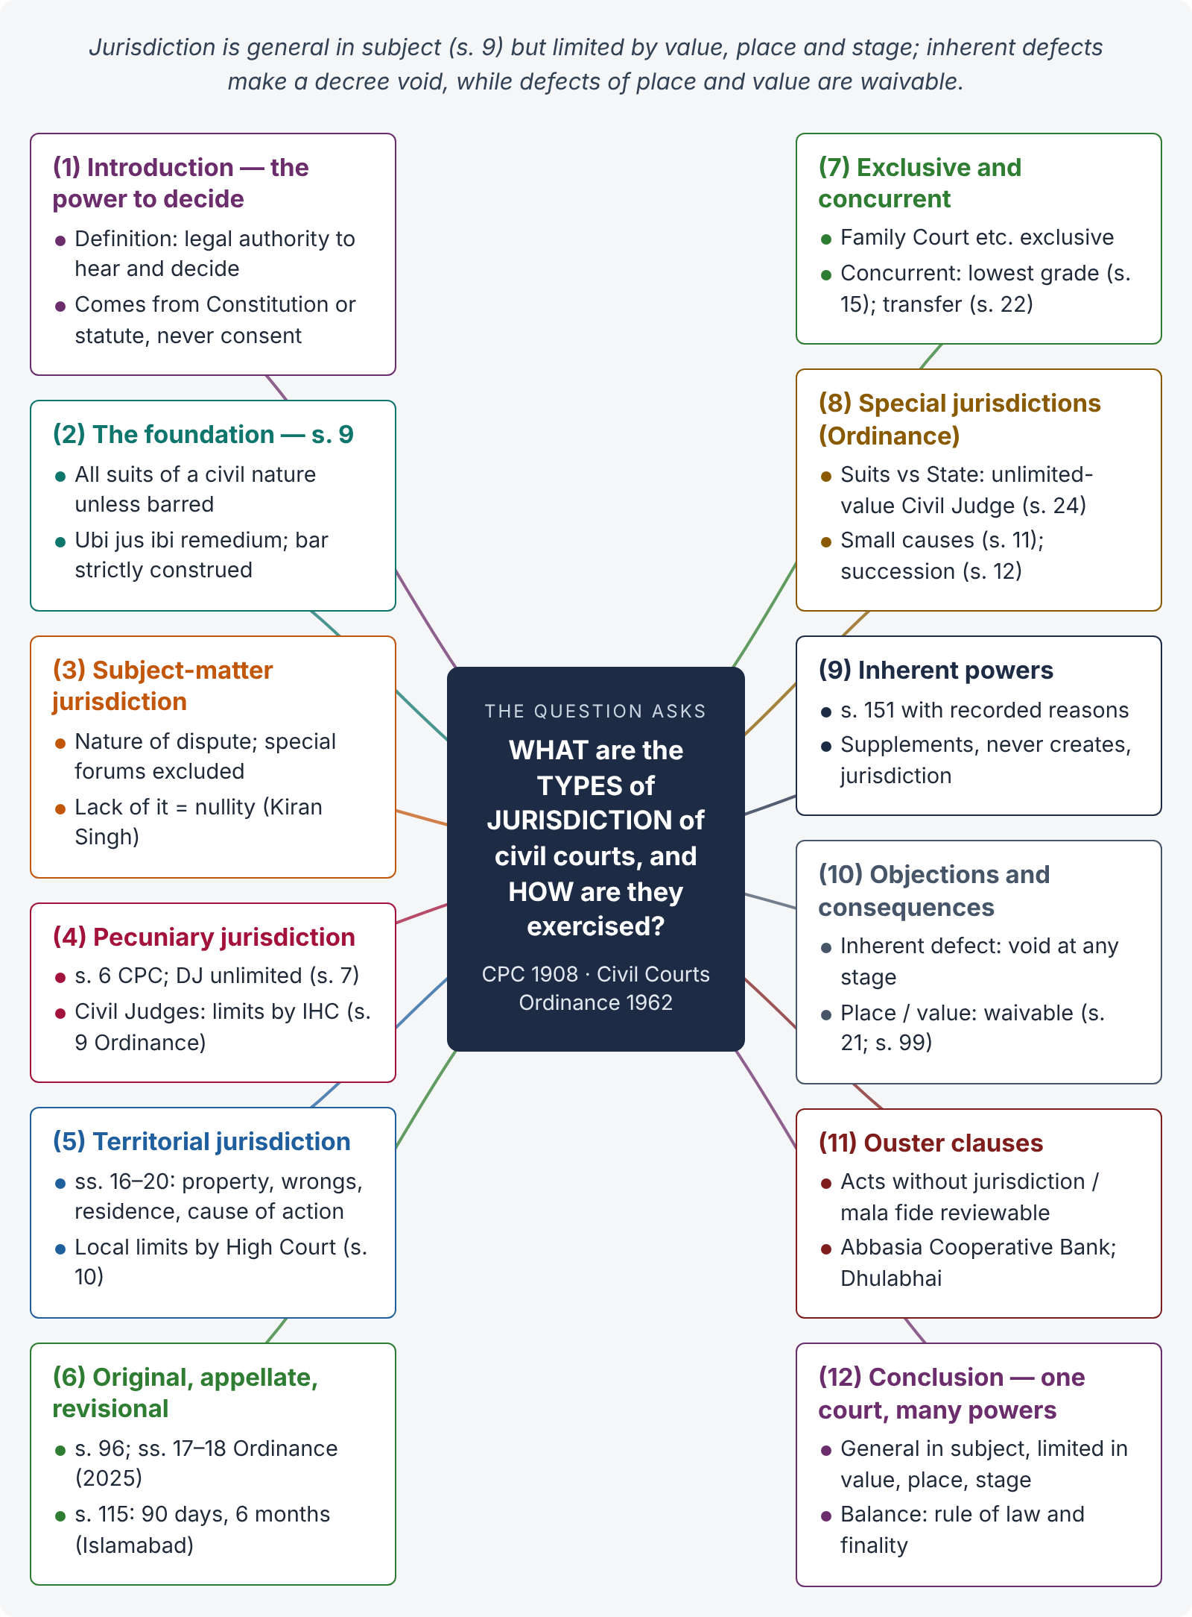
Figure 1 · The answer map: every branch is one numbered heading of the model answer below

Decoding the question
"What are the different types" — a classify-and-explain question. "How are these exercised" — the examiner wants the source of each kind of jurisdiction (CPC section or Civil Courts Ordinance section), who exercises it, and the rules and limits on its exercise (s. 15 lowest grade; s. 21 objections; nullity). Start with a definition and the basic rule of s. 9, explain each kind with its law and an example, then explain consequences of lack of jurisdiction, and end with the Islamabad position.

The model answer

1. Introduction — the power to decide

i) Definition
Jurisdiction is the legal authority of a court to hear and decide a cause. It comes from juris (law) and dictio (saying): the power to declare the law in a case. A court gets jurisdiction only from the Constitution or a statute; parties cannot confer it by consent.

ii) The argument
A civil court's jurisdiction is not one single power but a bundle: it is limited by the kind of dispute (subject matter), by money value (pecuniary), by place (territorial), and by the stage of the case (original, appellate, revisional). The Code of Civil Procedure 1908 (CPC) and the West Pakistan Civil Courts Ordinance 1962 together decide who exercises which power.

2. The foundation — s. 9 CPC

i) The rule
"The Courts shall (subject to the provisions herein contained) have jurisdiction to try all suits of a civil nature excepting suits of which their cognizance is either expressly or impliedly barred" (s. 9).

ii) Its meaning
Every civil right has a remedy (ubi jus ibi remedium). The civil court is the court of general jurisdiction; any exclusion must be shown and is strictly construed (Secretary of State v. Mask & Co., AIR 1940 PC 105).

3. Subject-matter (inherent) jurisdiction

i) The kind
Power over the nature of the dispute — suits of a civil nature (property, office, contract, tort, status). Disputes given exclusively to special forums (Family Court, Rent Controller, Banking Court) are outside it.

ii) How exercised
The court examines the plaint to see whether the suit is civil and not barred (s. 9). If barred, the plaint is rejected (O. VII r. 11(d)). Lack of subject-matter jurisdiction makes the decree a nullity and cannot be cured by consent (Kiran Singh v. Chaman Paswan, AIR 1954 SC 340).

4. Pecuniary jurisdiction

i) The kind
Power limited by the value of the suit: "nothing herein contained shall operate to give any Court jurisdiction over suits the amount or value of the subject matter of which exceeds the pecuniary limits, if any, of its ordinary jurisdiction" (s. 6 CPC, as substituted by Act XIX of 2023).

ii) How exercised
The District Judge has jurisdiction "in original civil suits without limit as regards the value" (s. 7, Ordinance). The value limit of each Civil Judge "shall be determined by the High Court either by including him in a class or otherwise" (s. 9, Ordinance). The plaintiff's valuation in the plaint (O. VII r. 1(i)) ordinarily decides the forum; if undervalued, the court requires correction (O. VII r. 11(b)) and, if beyond its limit, returns the plaint (O. VII r. 10).

5. Territorial (local) jurisdiction

i) The kind
Power limited to a geographical area. The High Court defines a Civil Judge's local limits; otherwise the district is his limit (s. 10, Ordinance).

ii) How exercised — ss. 16 to 20 CPC
Suits about immovable property lie where the property is situate (s. 16; s. 17 if in several districts); suits for wrongs to person or movables lie where the wrong was done or the defendant resides (s. 19); all other suits lie where the defendant resides, carries on business or personally works for gain, or where the cause of action wholly or partly arose (s. 20).

iii) Illustration
Ayesha, living in Islamabad, buys a car in Lahore from Junaid of Karachi; the car proves stolen. She may sue in Lahore (cause of action) or Karachi (residence) — s. 20.

6. Original, appellate and revisional jurisdiction

i) Original
The power to try a case at first instance — suits (s. 26) and original petitions. In Islamabad, Civil Judges and the District Judge exercise it.

ii) Appellate
The power to rehear a decided case on facts and law. A first appeal lies from every original decree (s. 96); from Civil Judges to the District Judge (s. 18(1) Ordinance, as substituted for Islamabad by Act XV of 2025) and from the District Judge / ADJ to the High Court (s. 17); second appeal on law to the High Court (s. 100).

iii) Revisional
The supervisory power of the High Court (and of the District Court within its appellate limits) to correct a subordinate court that has exercised a jurisdiction not vested in it, failed to exercise a vested jurisdiction, or acted illegally or with material irregularity, in a case where no appeal lies (s. 115). Islamabad text: application within ninety days, to be decided within six months.

7. Exclusive and concurrent jurisdiction

i) Exclusive
Only one forum may decide (e.g., Family Court for dower and maintenance under the Family Courts Act 1964). The civil court's jurisdiction is ousted.

ii) Concurrent
Several courts have jurisdiction (e.g., residence and cause of action at different places). The plaintiff, as dominus litis, chooses; but he must sue in the court of the lowest grade competent to try it (s. 15); the defendant may seek transfer (s. 22) and the High Court / District Court may transfer or withdraw (s. 24).

8. Special jurisdictions under the Civil Courts Ordinance

i) Suits against the State
Suits in which Pakistan, a Province or a public officer in his official capacity is a party may be entertained only by a Civil Judge having jurisdiction without limit as to value, at district headquarters (s. 24).

ii) Small cause and succession matters
The High Court may confer Small Cause Court jurisdiction on Civil Judges (s. 11) and authorise them to hear Succession Act proceedings (s. 12).

9. Inherent powers — not a separate jurisdiction
"Nothing in this Code shall be deemed to limit or otherwise affect the inherent power of the Court to be exercised after recording reasons to make such orders as may be necessary for the ends of justice or to prevent abuse of the process of the Court" (s. 151, Islamabad text after Act VII of 2020). It supplements, but never creates, jurisdiction.

10. Objections and consequences of want of jurisdiction

i) Inherent defect
A decree without subject-matter jurisdiction is void; the objection can be raised at any stage, even in execution (Kiran Singh).

ii) Territorial and pecuniary defects
They are waivable. "No objection as to the place of suing shall be allowed by any appellate or revisional Court unless such objection was taken in the Court of first instance at the earliest possible opportunity … and unless there has been a consequent failure of justice" (s. 21). The same approach applies to valuation (s. 11 Suits Valuation Act 1887). No decree is reversed for an irregularity not affecting the merits or jurisdiction (s. 99).

11. Exercise within limits — ouster clauses
Even where a special statute ousts civil courts, the civil court may still examine orders without jurisdiction, mala fide, coram non judice or against natural justice (Abbasia Cooperative Bank v. Hakeem Hafiz Muhammad Ghaus, PLD 1997 SC 3; Dhulabhai v. State of M.P., AIR 1969 SC 78).

12. Conclusion — one court, many powers
A civil court's jurisdiction is general in subject (s. 9) but limited by value (s. 6; ss. 7, 9 Ordinance), place (ss. 15–20) and stage (original, appellate, revisional). It is exercised by District Judges, ADJs and Civil Judges in the hierarchy laid down by the Civil Courts Ordinance, which s. 3 CPC adopts for Islamabad. The law treats defects of inherent jurisdiction as fatal, but defects of place and value as curable — balancing the rule of law against the need to end litigation.

Why this answer scores
- It defines jurisdiction and anchors everything in s. 9, the master section.
- Each kind is explained with its source (CPC or Ordinance section) and how it is exercised — the second half of the question that weak answers ignore.
- Islamabad-specific law is used: s. 6 (2023), s. 18(1) Ordinance (2025), s. 115 time limits, s. 151 reasons.
- Leading cases support each legal point: Kiran Singh, Mask & Co., Dhulabhai, Abbasia Cooperative Bank.
- The consequences of lack of jurisdiction (void vs waivable) show depth.

Answer 2 · Forums of civil appeal under the Civil Courts Ordinance 1962 (KPHC 2026)
AT A GLANCE · KP HIGH COURT 2026 · CIVIL LAW-I · Q. 6 · 20 MARKS
Explain the concept and forums of different civil appeals briefly as provided in the Civil Courts Ordinance, 1962. (Related: LHC 2023 General Law, Q. 10 — "Is it lawful for a Civil Judge to act as District Court for the purposes of appeal(s) preferred against the decree / order passed in any original suit by any Civil Judge?")

The answer map
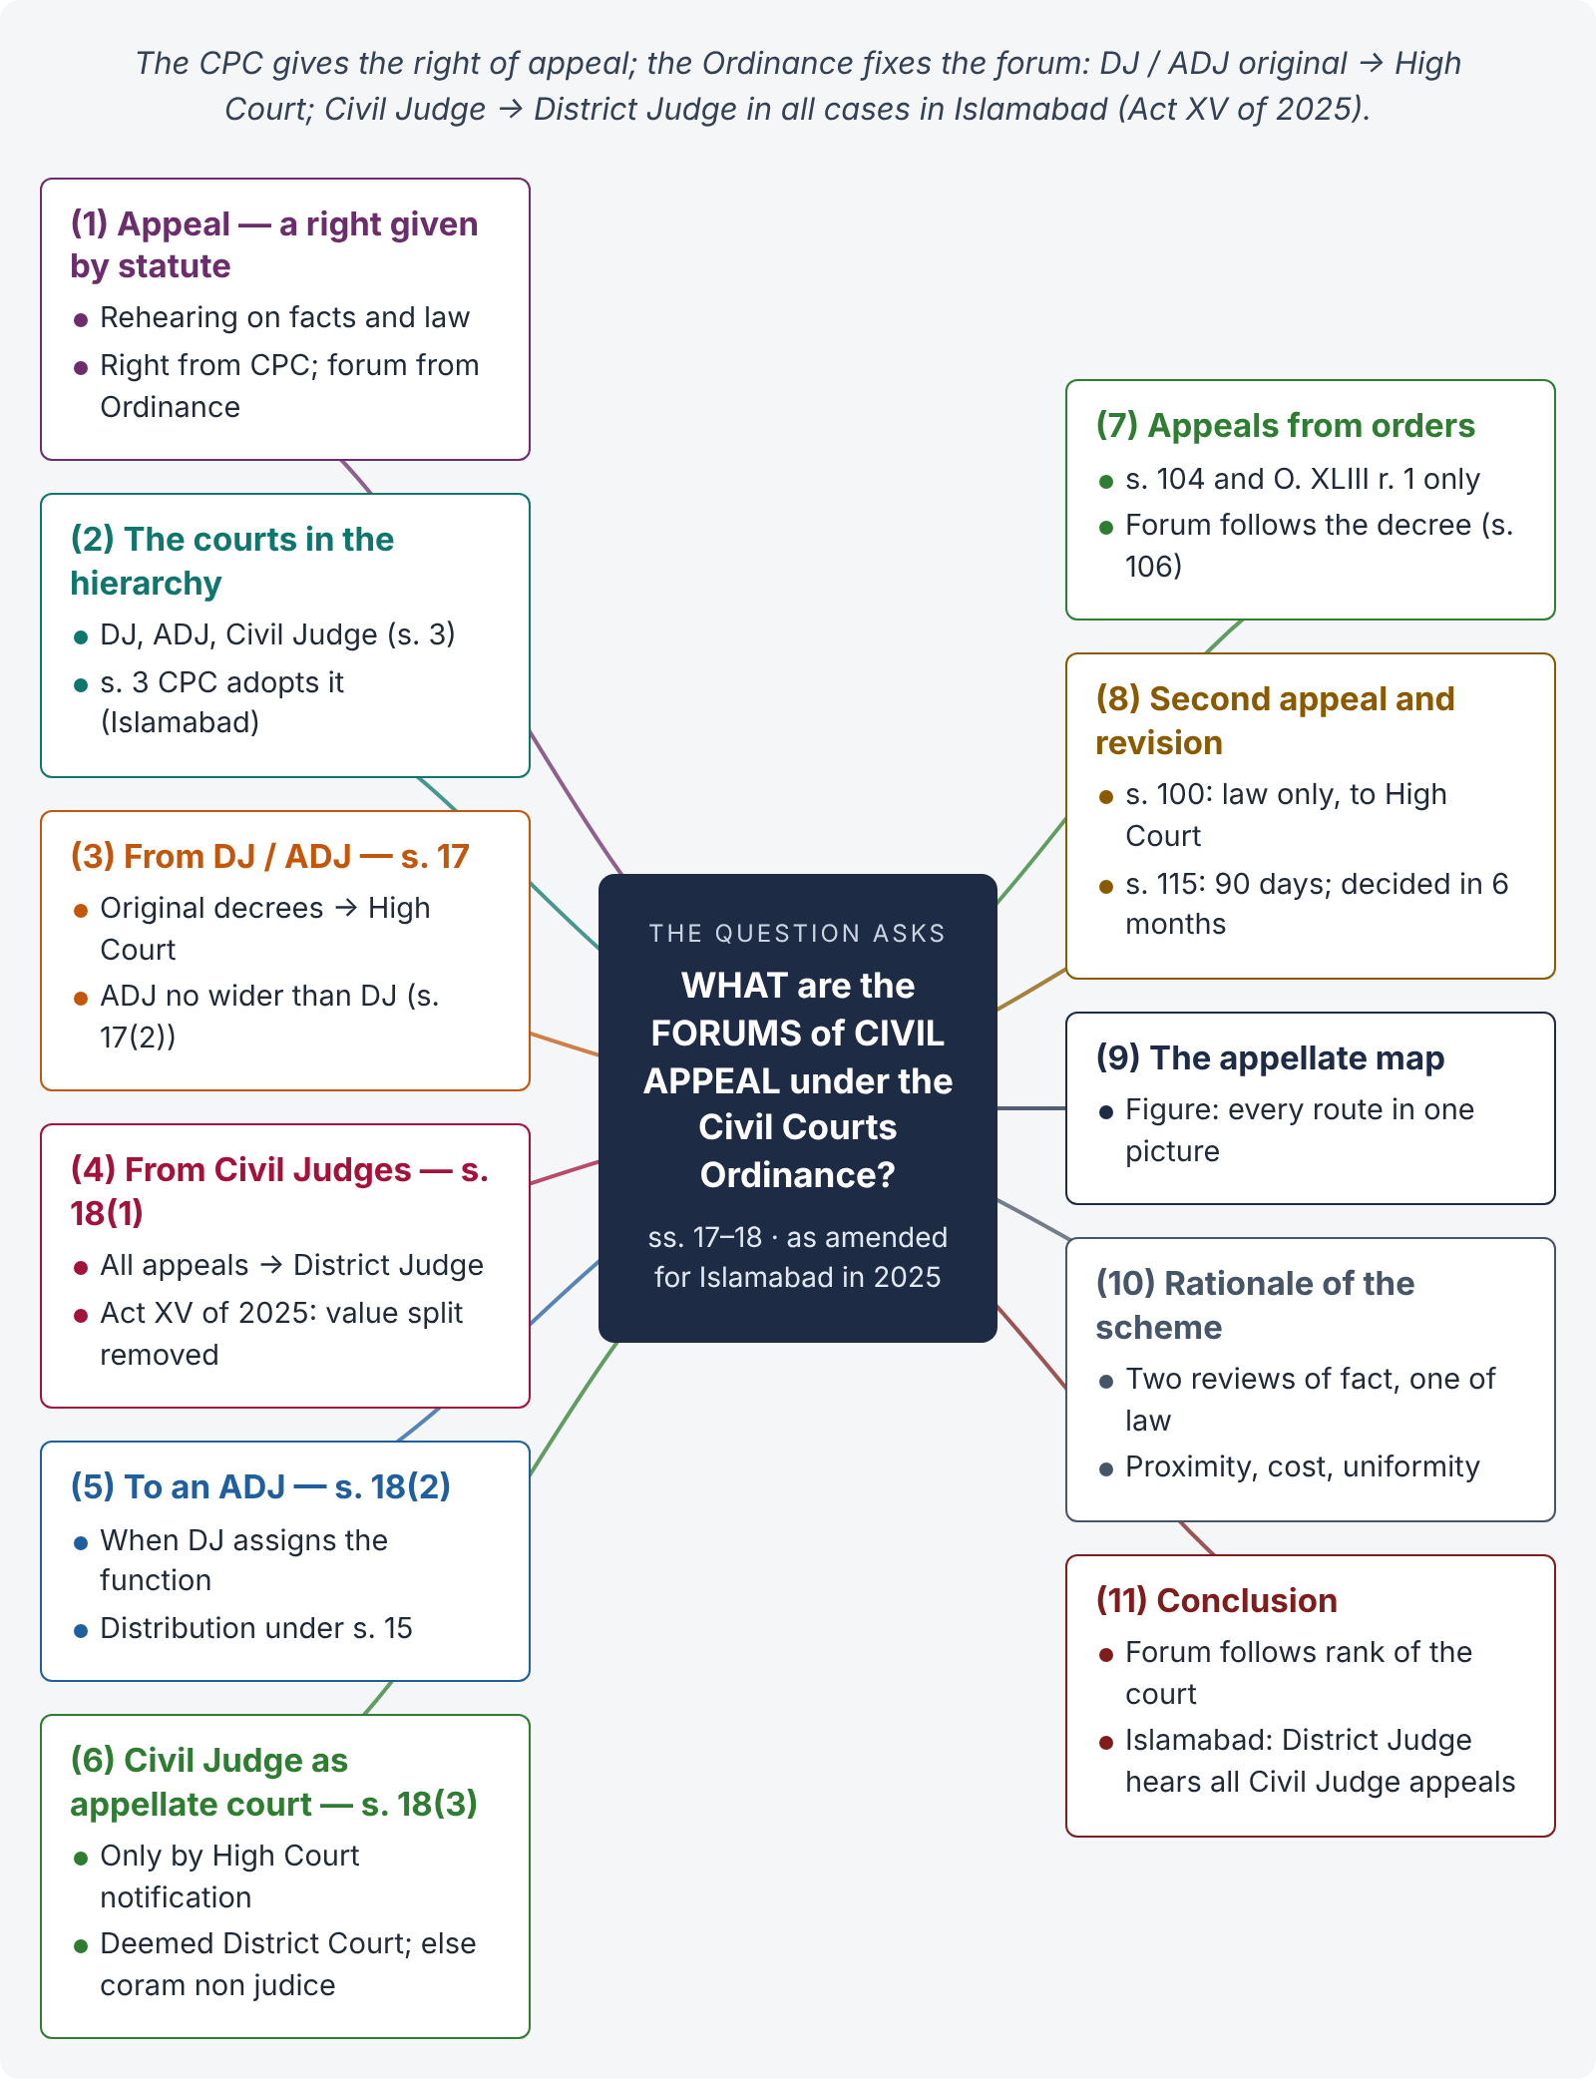
Figure 2 · The answer map: every branch is one numbered heading of the model answer below

Decoding the question
Two parts: (1) the concept of an appeal — what it is, that it is a creature of statute, and how the CPC and the Ordinance work together; (2) the forums — ss. 17 and 18 of the Ordinance, with the Islamabad amendment of 2025 and the special rule in s. 18(3). A first-class answer also explains the second appeal and revision that follow, and draws the full appellate map.

The model answer

1. Introduction — appeal as a right given by statute

i) Meaning
An appeal is the removal of a case from a lower court to a higher court for a rehearing on facts and law, so that the higher court may confirm, reverse or vary the decision. A first appeal is a continuation of the suit: the appellate court has "the same powers … as are conferred … on Courts of original jurisdiction" (s. 107(2) CPC).

ii) A creature of statute
There is no inherent right of appeal. It exists only if a statute gives it. The CPC creates the right (s. 96: appeal from every original decree; s. 104 and O. XLIII: appeals from listed orders). The Civil Courts Ordinance 1962 decides the forum — to which court the appeal goes. A right of appeal is a substantive right that vests on the date of the suit.

2. The courts in the hierarchy
"There shall be the following classes of Civil Courts, namely:— (a) the Court of the District Judge; (b) the Court of the Additional District Judge; and (c) the Court of the Civil Judge" (s. 3, Ordinance). For Islamabad, s. 3 CPC (as substituted by Act VII of 2020) adopts the same hierarchy for the purposes of the Code. All civil courts are subordinate to the High Court, and the District Judge controls the courts in his district (s. 14).

3. Appeals from District Judges and Additional District Judges — s. 17

i) The rule
"Save as otherwise provided by any enactment for the time being in force, an appeal from a decree or order of a District Judge or Additional District Judge exercising original jurisdiction shall lie to the High Court" (s. 17(1)).

ii) The limit for ADJs
"An appeal shall not lie to the High Court from a decree or order of an Additional District Judge in any case in which, if the decree or order had been made by the District Judge, an appeal would not lie to that Court" (s. 17(2)). The ADJ exercises the District Judge's powers (s. 6(2)); his orders have no wider appealability than the District Judge's.

4. Appeals from Civil Judges — s. 18(1) (Islamabad, 2025)

i) The rule after Act XV of 2025
"Save as aforesaid, an appeal from a decree or order of a Civil Judge shall lie to the District Judge" (s. 18(1), substituted by Act No. XV of 2025 in its application to the Islamabad Capital Territory).

ii) What changed
Previously, s. 18(1) split appeals by value — high-value appeals from Civil Judges went to the High Court. In Islamabad, all appeals from Civil Judges now go to the District Judge, irrespective of value. The IHC accordingly transferred pending appeals of this kind to the District Judges in 2025. The amendment brings appeals closer to the litigant and reduces the High Court's first-appeal workload.

5. Appeals to an Additional District Judge — s. 18(2)
"Where the function of receiving any appeals which lie to the District Judge under the last preceding sub-section has been assigned to an Additional District Judge, the appeal may be preferred to the Additional District Judge." In practice, the District Judge distributes appeals among ADJs under s. 15.

6. A Civil Judge as appellate court — s. 18(3)

i) The rule
"The High Court may, by notification, direct that appeals lying to the District Judge from all or any of the decrees or orders passed in any original suit by any Civil Judge shall be referred to such other Civil Judge as may be mentioned in the notification … and the Court of such Civil Judge shall be deemed to be a District Court for the purposes of all appeals so preferred."

ii) Answer to the LHC 2023 question
It is lawful for a Civil Judge to hear appeals only if the High Court has issued a notification under s. 18(3). Without it, a Civil Judge has no appellate jurisdiction; an appeal decided by him would be coram non judice and void.

7. Appeals from orders
Only orders listed in s. 104 CPC and O. XLIII r. 1 are appealable — e.g., an order returning a plaint (r. 1(a)), refusing to set aside an ex parte decree (r. 1(d)), or granting or refusing a temporary injunction (r. 1(r)). Such appeals go to the court to which an appeal from the decree in that suit would lie (s. 106 CPC) — so, in Islamabad, from a Civil Judge to the District Judge.

8. Further remedies — second appeal and revision

i) Second appeal — s. 100 CPC
From an appellate decree of the District Judge / ADJ to the High Court, on law only: decision contrary to law or usage having the force of law; failure to determine a material issue of law; or a substantial procedural error that may have affected the decision on merits.

ii) Revision — s. 115 CPC
Where no appeal lies, the High Court (or the District Court within its appellate limits) may revise jurisdictional errors. The Islamabad text requires the application "within ninety days" of the decision, with copies of pleadings and the order, and disposal "within six months".

9. The complete appellate map for Islamabad
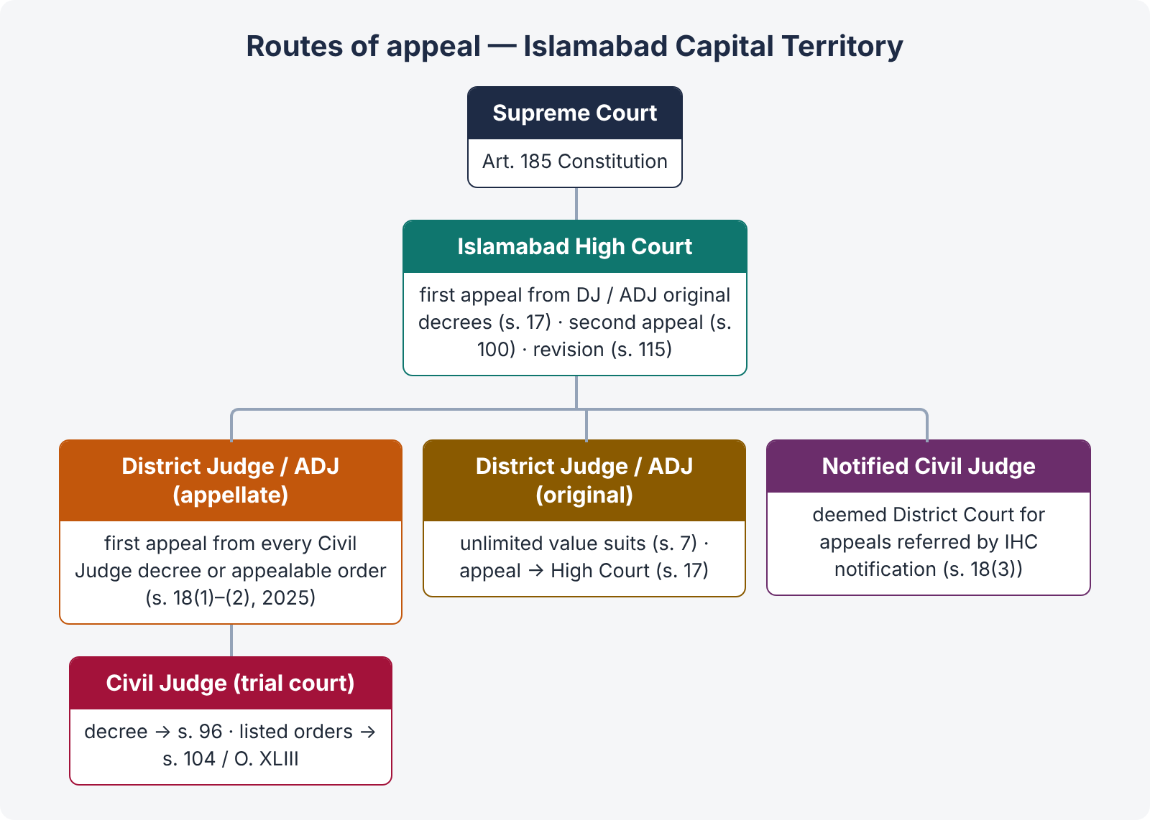
Figure 3 · Appeals from civil courts in Islamabad after the 2025 amendment

10. Rationale of the scheme
- Two levels of factual review, one of legal review: trial court → first appeal (facts and law) → second appeal (law only). Facts are finally settled at the first appellate stage.
- Proximity and cost: appeals from Civil Judges are heard within the district.
- Uniformity of law: the High Court's second-appeal and revisional powers keep the law uniform across the ICT.

11. Conclusion
Under the Civil Courts Ordinance, the forum of a civil appeal follows the rank of the court that decided the case: District Judge / ADJ (original) → High Court (s. 17); Civil Judge → District Judge in every case in Islamabad after Act XV of 2025 (s. 18(1)), or an ADJ to whom appeals are assigned (s. 18(2)), or a Civil Judge notified by the High Court (s. 18(3)). The CPC supplies the right (ss. 96, 104), the further remedies (ss. 100, 115) and the procedure (O. XLI).

Why this answer scores
- It separates the right of appeal (CPC) from the forum (Ordinance) — the key conceptual point.
- It states the 2025 Islamabad amendment of s. 18(1) — few candidates will know it.
- It directly answers the LHC 2023 question on s. 18(3) with the consequence (coram non judice).
- The appellate map figure shows the whole system at a glance.

Answer 3 · "Courts to try all civil suits unless barred" — s. 9 CPC (LHC ASJ 2020)
AT A GLANCE · LHC ASJ EXAM 2020 · CIVIL LAW-II · Q. 2 · 20 MARKS
Courts to try all civil suits unless barred. Discuss all aspects.

The answer map
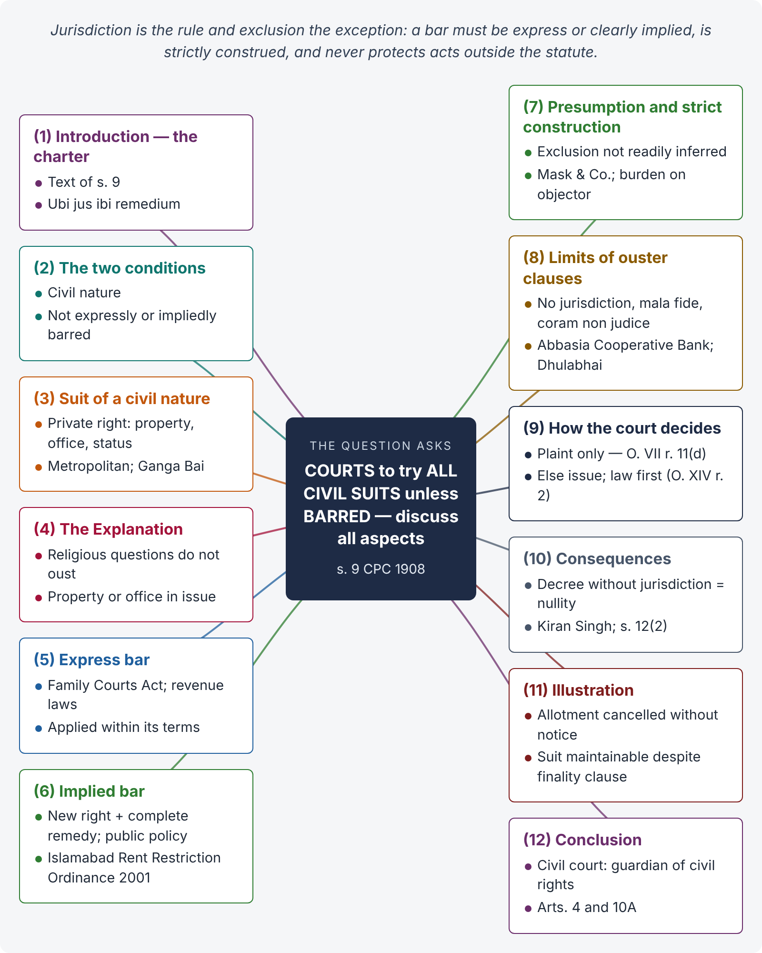
Figure 4 · The answer map: every branch is one numbered heading of the model answer below

Decoding the question
"Discuss all aspects" means: the text of s. 9, its two conditions (civil nature; no bar), the Explanation, the presumption in favour of jurisdiction, express and implied bars, the limits of ouster clauses, who bears the burden, how the court decides the question, and the consequence of lack of jurisdiction. Use cases from Pakistan, India and the Privy Council.

The model answer

1. Introduction — the charter of civil jurisdiction
"The Courts shall (subject to the provisions herein contained) have jurisdiction to try all suits of a civil nature excepting suits of which their cognizance is either expressly or impliedly barred" (s. 9 CPC). The section expresses the maxim ubi jus ibi remedium — where there is a right, there is a remedy — and gives every person a forum for the enforcement of civil rights.

2. The two conditions
A civil court has jurisdiction under s. 9 when (i) the suit is of a civil nature, and (ii) its cognizance is not barred, expressly or impliedly. Both must be satisfied.

3. "Suit of a civil nature"

i) Meaning
"Civil" refers to private rights and remedies of a person, as distinguished from criminal, political or purely religious matters. A suit is of a civil nature if its principal question concerns a civil right — property, office, status, contract or tort.

ii) Case law
In Most Rev. P.M.A. Metropolitan v. Moran Mar Marthoma (AIR 1995 SC 2001) the Supreme Court of India held that the language of s. 9 is mandatory ("shall"); the court is bound to try every civil suit unless barred. In Ganga Bai v. Vijay Kumar (AIR 1974 SC 1126) it held that every person has an inherent right to bring a civil suit; no statutory authority is needed to sue, only the absence of a bar.

iii) Illustrations
Civil: right to property, to an office with emoluments (imam, mutawalli), to worship in a public mosque, to salary, to damages. Not civil: a mere question of social precedence, caste dignity or religious honour without any right to property or office.

4. The Explanation — religious questions
"A suit in which the right to property or to an office is contested is a suit of a civil nature, notwithstanding that such right may depend entirely on the decision of questions as to religious rites or ceremonies." So a suit about the right to the office of mutawalli remains civil even if the court must decide a religious qualification.

5. Express bar
A statute may say in words that civil courts shall not entertain a matter — e.g., the Family Courts Act 1964 (exclusive jurisdiction of Family Courts over matters in its Schedule), or bar clauses in the West Pakistan Land Revenue Act 1967 for matters within revenue officers' jurisdiction. The court must give effect to the bar within its terms.

6. Implied bar

i) When implied
Without words of exclusion, a bar is implied where (a) a statute creates a new right unknown to the general law and in the same statute provides a complete machinery — forum, appeal and revision — to enforce it; or (b) public policy forbids the suit (e.g., a suit for a gambling debt, or about an act of State).

ii) Example
The Islamabad Rent Restriction Ordinance 2001 creates the landlord's statutory right to evict on specified grounds and gives exclusive jurisdiction to the Rent Controller. A civil suit for eviction of a tenant is barred.

7. Presumption and strict construction
The exclusion of civil court jurisdiction "is not to be readily inferred; such exclusion must be either explicitly expressed or clearly implied" (Secretary of State v. Mask & Co., AIR 1940 PC 105). The burden lies on the party who asserts the bar, and ouster provisions are construed strictly, in favour of jurisdiction.

8. Limits of ouster clauses

i) The Pakistani rule
Even where a statute ousts the civil court, it may still examine whether the special forum acted without jurisdiction, mala fide, coram non judice, or in violation of natural justice — because such acts are not acts "under" the statute (Abbasia Cooperative Bank v. Hakeem Hafiz Muhammad Ghaus, PLD 1997 SC 3).

ii) The Dhulabhai tests
Dhulabhai v. State of M.P. (AIR 1969 SC 78) holds that finality clauses exclude civil courts only where the statute provides an adequate remedy; civil courts may still examine non-compliance with the Act or with fundamental principles of judicial procedure; challenges to the vires of the Act may be brought by suit; and where a statute creates a special right with a special remedy, that remedy is ordinarily exclusive.

9. How the court decides the question
Jurisdiction is decided first on the averments in the plaint (O. VII r. 11(d) — "barred by any law"). If the bar is apparent from the plaint, the plaint is rejected; if it depends on disputed facts, an issue is framed and, where it is a pure question of law, tried first (O. XIV r. 2).

10. Consequences of lack of jurisdiction
A decree passed by a court that lacked subject-matter jurisdiction is a nullity and can be challenged at any stage, even in execution (Kiran Singh v. Chaman Paswan, AIR 1954 SC 340); in Pakistan, a decree passed without jurisdiction may be challenged under s. 12(2) CPC by application to the court that passed it.

11. Illustration — applying s. 9
The Capital Housing Authority cancels Bilal's plot allotment without notice; its statute says its orders "shall not be called in question in any court". Bilal sues for a declaration that the cancellation is void. The suit is maintainable: the cancellation without hearing violates natural justice and is not an order "under" the statute (Abbasia Cooperative Bank). Had the Authority given notice and decided within its powers, the civil court could not reappraise the merits.

12. Conclusion
Section 9 makes the civil court the ordinary guardian of civil rights: jurisdiction is the rule, exclusion the exception. A bar must be express or clearly implied, is strictly construed, and never protects acts outside the statute, in bad faith or against natural justice. This balance respects the legislature's power to create special forums while preserving the citizen's access to justice under Articles 4 and 10A of the Constitution.

Why this answer scores
- It covers "all aspects" systematically: text, conditions, Explanation, express and implied bars, presumption, ouster limits, procedure, consequences.
- Authority at every step: Privy Council (Mask), India (Metropolitan, Ganga Bai, Dhulabhai, Kiran Singh) and Pakistan (Abbasia Cooperative Bank).
- Islamabad example (Rent Restriction Ordinance 2001) and a practical illustration.
- Constitutional link (Arts. 4, 10A) in the conclusion lifts the answer above a textbook summary.

Answer 4 · Res judicata and res sub judice; constructive res judicata (LLB standard)
AT A GLANCE · PUNJAB UNIVERSITY LLB (CPC) 2008 & 2009 · STANDARD JUDICIAL-EXAM QUESTION · 20 MARKS
Define and distinguish between the two legal terms res sub judice and res judicata. Explain the doctrine of constructive res judicata with illustrations.

The answer map
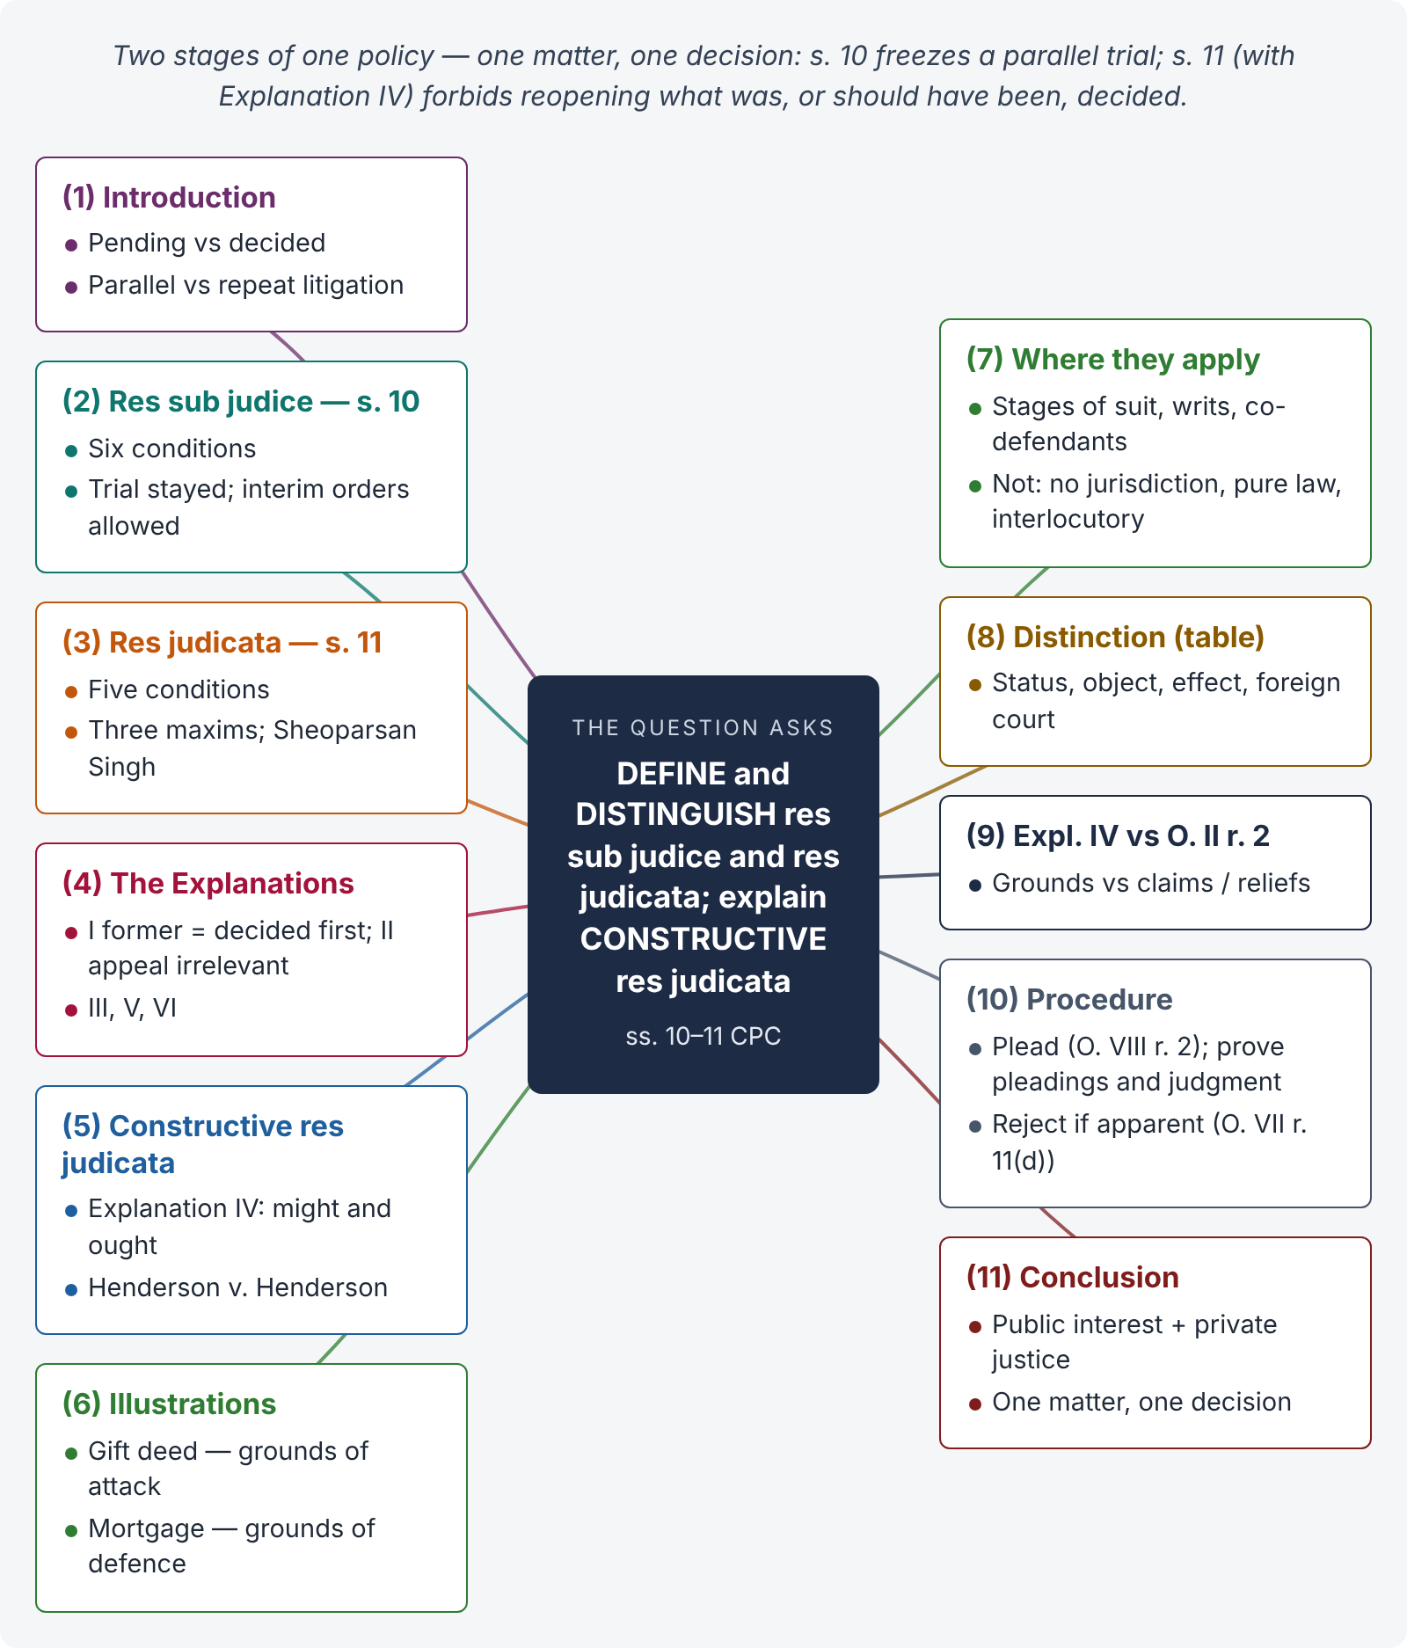
Figure 5 · The answer map: every branch is one numbered heading of the model answer below

Decoding the question
Three tasks: define each doctrine (ss. 10 and 11), distinguish them point by point (a table is ideal), and explain constructive res judicata (Explanation IV) with illustrations. Give the conditions of each doctrine, the policy (maxims), and leading cases. A comparison table near the end earns quick marks.

The model answer

1. Introduction — two guards against repeated litigation
Both doctrines protect the courts and the parties from multiplicity of litigation and conflicting decisions. Res sub judice deals with a matter pending before a court; res judicata with a matter already decided. Section 10 CPC stops a parallel trial; s. 11 stops a repeat trial.

2. Res sub judice — s. 10

i) The provision
"No Court shall proceed with the trial of any suit in which the matter in issue is also directly and substantially in issue in a previously instituted suit between the same parties, or between parties under whom they or any of them claim litigating under the same title where such suit is pending in the same or any other Court in Pakistan having jurisdiction to grant the relief claimed …" (s. 10).

ii) Conditions
(1) Two suits, one previously instituted; (2) the matter in issue directly and substantially the same; (3) same parties or their privies; (4) litigating under the same title; (5) the earlier suit pending; (6) in a court in Pakistan (or a federally established court abroad, or the Supreme Court) competent to grant the relief claimed in the later suit.

iii) Effect
Only the trial of the later suit is stayed; it may be instituted, and interim orders may be passed. A decree in breach of s. 10 is not a nullity. The court may consolidate both suits under s. 151. A suit pending in a foreign court is no bar (Explanation).

3. Res judicata — s. 11

i) The provision
"No Court shall try any suit or issue in which the matter directly and substantially in issue has been directly and substantially in issue in a former suit between the same parties, or between parties under whom they or any of them claim, litigating under the same title, in a Court competent to try such subsequent suit or the suit in which such issue has been subsequently raised, and has been heard and finally decided by such Court" (s. 11).

ii) Conditions
(1) Matter directly and substantially in issue in both suits; (2) same parties or privies; (3) same title; (4) former court competent to try the later suit; (5) heard and finally decided on merits.

iii) Policy — three maxims
Nemo debet bis vexari pro una et eadem causa (no one twice vexed for the same cause), interest reipublicae ut sit finis litium (public interest in an end to litigation), and res judicata pro veritate accipitur (a decided matter is accepted as true). The Privy Council called it a rule of universal law, founded on public policy and private justice (Sheoparsan Singh v. Ramnandan Prasad Singh, (1916) 43 IA 91).

4. The Explanations to s. 11
- I — "former suit" is the suit decided first, whether or not instituted first.
- II — competence is judged irrespective of a right of appeal.
- III — the matter must have been alleged by one party and denied or admitted by the other.
- IV — constructive res judicata (below).
- V — relief claimed but not expressly granted is deemed refused.
- VI — persons litigating bona fide about a public or common right bind all interested (representative suits).

5. Constructive res judicata — Explanation IV

i) The rule
"Any matter which might and ought to have been made ground of defence or attack in such former suit shall be deemed to have been a matter directly and substantially in issue in such suit."

ii) Meaning and rationale
A party must bring his whole case forward at once. Grounds he could and should have raised, but did not, are treated as if raised and decided. Otherwise a litigant could split his case into many suits and harass the other side indefinitely.

iii) Source of the rule
Henderson v. Henderson ((1843) 3 Hare 100): the court requires parties "to bring forward their whole case", and will not allow the same subject to be reopened on matters which might have been brought forward but were omitted "from negligence, inadvertence, or even accident".

6. Illustrations of constructive res judicata

i) Grounds of attack
Rizwan sues to set aside his father's gift of a house in F-7 on the ground of undue influence and loses. He then sues to set aside the same gift on the ground of fraud and non-delivery of possession. Those grounds were available and ought to have been taken in the first suit; the second suit is barred.

ii) Grounds of defence
In a mortgagee's suit for recovery, the mortgagor does not plead that the mortgage was void for want of registration. After a decree, he files a suit for a declaration that the mortgage was void for the same reason. Barred — it "might and ought to" have been a ground of defence.

7. Where the doctrines apply — and where they do not
Res judicata applies between stages of the same suit (Satyadhyan Ghosal v. Deorajin Debi, AIR 1960 SC 941), to writ petitions decided on merits (Daryao v. State of U.P., AIR 1961 SC 1457), between co-defendants where there was a conflict between them that had to be decided, and to ex parte decrees. It does not apply to decisions without jurisdiction, to a pure question of law wrongly decided on jurisdiction (Mathura Prasad v. Dossibai, AIR 1971 SC 2355), or to interlocutory orders regulating procedure (Arjun Singh v. Mohindra Kumar, AIR 1964 SC 993).

8. Distinction — res sub judice and res judicata
Basis | Res sub judice (s. 10) | Res judicata (s. 11)
Status of the earlier matter | Pending in a court | Decided finally
Object | Prevent parallel trials and conflicting decisions | Prevent repeat litigation; give finality
What is barred | Trial of the later suit (institution allowed) | Trial of the later suit or issue
Which suit is "earlier" | The previously instituted suit | The suit decided first (Expl. I)
Constructive form | None | Explanation IV
Effect of breach | Decree not a nullity; irregular | Decree in breach liable to be set aside; plea must be taken
Foreign court | Pending foreign suit no bar | Foreign judgment may bind under s. 13

9. Constructive res judicata and O. II r. 2 distinguished
Explanation IV concerns grounds (arguments, facts) of attack or defence; O. II r. 2 concerns claims or reliefs omitted from the same cause of action ("he shall not afterwards sue in respect of the portion so omitted"). Both serve finality, but they are separate rules.

10. Procedure — raising and proving the plea
Res judicata must be specifically pleaded (O. VIII r. 2) and proved by certified copies of the pleadings, issues and judgment of the former suit; if apparent from the plaint, the plaint may be rejected as "barred by any law" (O. VII r. 11(d)).

11. Conclusion
Res sub judice and res judicata are two stages of one policy: one matter, one decision. Section 10 freezes a parallel trial while the first is pending; s. 11, with constructive res judicata in Explanation IV, forbids reopening what was decided — or what should have been raised — in the first suit. Together they serve the interest of the State in ending litigation and the right of the individual not to be vexed twice.

Why this answer scores
- Both doctrines are defined with the statutory text and conditions, not just described.
- The comparison table answers the "distinguish" part efficiently.
- Constructive res judicata is explained with its source case (Henderson) and two illustrations (attack and defence), as the question demands.
- The answer shows depth by marking the limits of res judicata and separating Explanation IV from O. II r. 2.

Answer 5 · Precept, executing court and the forum for s. 12(2) (LHC 2023)
AT A GLANCE · LHC CIVIL JUDGE EXAM 2023 · CIVIL LAW-II · Q. 6 · 20 MARKS
Whether the court to which precept is sent enjoys equal powers as the court which had passed the decree originally? If precept has been sent to Civil Court at Hyderabad by the Civil Court at Lahore, where would the application under section 12(2) of the Code of Civil Procedure 1908 lie — before the Court at Lahore or Hyderabad? Support your answer with reasoning.

The answer map
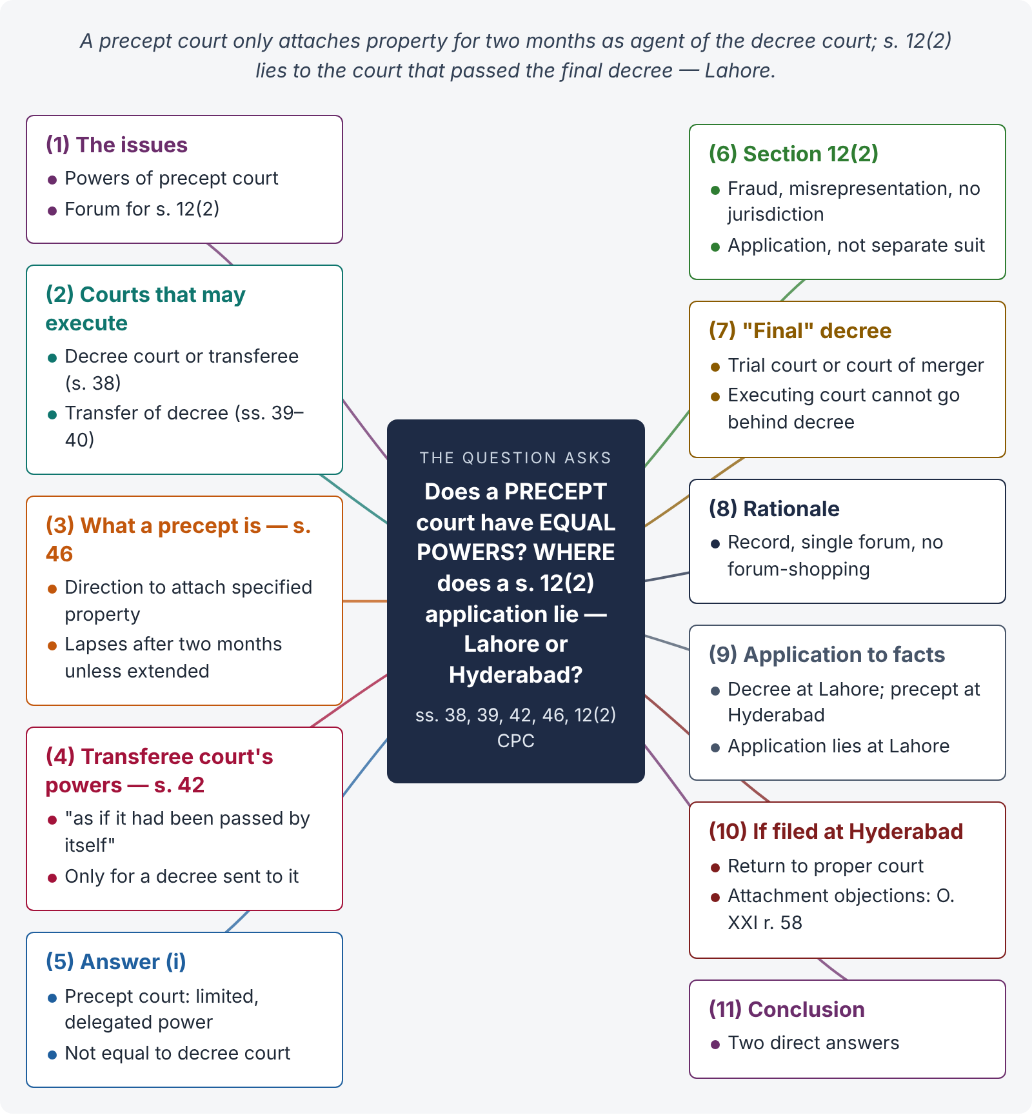
Figure 6 · The answer map: every branch is one numbered heading of the model answer below

Decoding the question
Two linked questions. (1) Precept (s. 46): what powers does the precept court have, compared with the decree-passing court and with a transferee executing court (ss. 39, 42)? (2) Section 12(2): which court is "the Court which passed the final judgment, decree or order"? The answer requires reading three provisions together — ss. 46, 42 and 12(2) — and applying them to the Lahore–Hyderabad facts.

The model answer

1. Introduction — the issues
Two questions arise: (i) whether a court receiving a precept acquires the same powers as the court that passed the decree; and (ii) whether an application under s. 12(2) challenging the decree lies at Lahore (decree court) or Hyderabad (precept court).

2. Courts that may execute a decree
"A decree may be executed either by the Court which passed it, or by the Court to which it is sent for execution" (s. 38). The decree-passing court may transfer the decree for execution to another court where the judgment-debtor resides or has property (s. 39), including a court in another province under its rules (s. 40).

3. What a precept is — s. 46

i) The provision
"Upon the application of the decree-holder the Court which passed the decree may, whenever it thinks fit, issue a precept to any other Court which would be competent to execute such decree to attach any property belonging to the judgment-debtor and specified in the precept" (s. 46(1)).

ii) Its limited life
"Provided that no attachment under a precept shall continue for more than two months unless the period of attachment is extended by an order of the Court which passed the decree or unless before the determination of such attachment the decree has been transferred to the Court by which the attachment has been made and the decree-holder has applied for an order for the sale of such property" (proviso to s. 46(2)).

iii) Purpose
A precept is an emergency, protective measure: it freezes the judgment-debtor's property in another district quickly, before he can dispose of it, while the formal transfer of the decree is arranged.

4. Powers of a transferee executing court — s. 42
"The Court executing a decree sent to it shall have the same powers in executing such decree as if it had been passed by itself" (s. 42(1)). Sub-section (2) lists powers such as further transfer (s. 39), execution against legal representatives (s. 50(1)), correction of clerical errors (s. 152), recognising an assignment of the decree (O. XXI r. 16) and notice of attachment of another decree (O. XXI r. 53(1)(b)). These powers belong to a court to which the decree itself has been sent under s. 39.

5. Answer to question (i) — the precept court's powers are limited

i) Conclusion
The court receiving a precept does not enjoy equal powers with the decree-passing court. Its only function is to attach the property specified in the precept, "in the manner prescribed in regard to the attachment of property in execution of a decree" (s. 46(2)). It cannot sell the property, decide objections on the merits of the decree, or exercise the general powers of s. 42 — unless and until the decree is transferred to it under s. 39.

ii) Reasoning
Section 42 speaks of "a decree sent to it" for execution; a precept is not the decree but a direction to attach. The precept court acts as the agent of the decree-passing court, which keeps control (it alone can extend the two-month attachment).

6. Section 12(2) — the provision
"Where a person challenges the validity of a judgment, decree or order on the plea of fraud, mis-representation or want of jurisdiction, he shall seek his remedy by making an application to the Court which passed the final judgment, decree or order and not by a separate suit" (s. 12(2), added by Ordinance X of 1980).

7. Meaning of "the Court which passed the final judgment, decree or order"

i) The test
The application lies to the court whose decision is final on the merits — the trial court, or, if its decree merged into an appellate or revisional decision on merits, the appellate / revisional court.

ii) Why not the executing court
An executing court — still less a precept court — does not pass the decree; it only enforces it. It cannot go behind the decree (s. 47 confines it to questions of execution, discharge and satisfaction). Section 12(2) attacks the validity of the decree itself; only the court that created it (or the final court) can undo it.

8. Rationale of the forum rule
The decree court has the record and knows the proceedings in which the fraud is alleged to have occurred; a single forum avoids conflicting decisions and prevents the judgment-debtor from choosing a convenient court far from the decree-holder.

9. Application to the facts

i) The decree
The decree was passed by the Civil Court at Lahore. No appeal is stated; Lahore's decree is the "final" decree.

ii) The precept
The Hyderabad court received only a precept to attach property under s. 46. It has not passed any judgment, decree or order on the merits.

iii) Result
The application under s. 12(2) lies before the Civil Court at Lahore, not Hyderabad. (If the Lahore decree had been appealed and decided on merits by the appellate court at Lahore, the application would lie to that appellate court.)

10. Remedy if filed at Hyderabad
If the judgment-debtor files the s. 12(2) application at Hyderabad, that court should return it for presentation to the proper court at Lahore (applying O. VII r. 10 through s. 141), not decide it. The Hyderabad court may, however, receive objections to attachment under O. XXI r. 58, which concern the attachment itself, not the decree's validity.

11. Conclusion
(i) A precept court has limited, delegated power to attach property for two months; it does not have the powers of the decree court or of a transferee court under s. 42 unless the decree is transferred to it. (ii) An application under s. 12(2) lies to the court that passed the final judgment or decree — on these facts, the Civil Court at Lahore.

Why this answer scores
- It reads ss. 38, 39, 42, 46 and 12(2) together, which the question tests.
- It quotes the two-month limit in s. 46 and the "sent to it" wording of s. 42 — the textual keys to the answer.
- The reasoning on "final judgment" and merger shows depth.
- It gives a clear, direct answer to each part, as a judge would.

Answer 6 · Amendment, rejection and return of plaint (SHC 2022 · KPHC 2026)
AT A GLANCE · SINDH HIGH COURT 2022 · CIVIL LAW · Q. 3 · 20 MARKS
What are the grounds for the following: (a) amendment of plaint; (b) rejection of plaint; (c) return of plaint? (KP High Court 2026, Q. 2: "What is the difference between 'return of plaint' and 'rejection of plaint'? On what grounds court proceed in both cases? Elaborate.")

The answer map
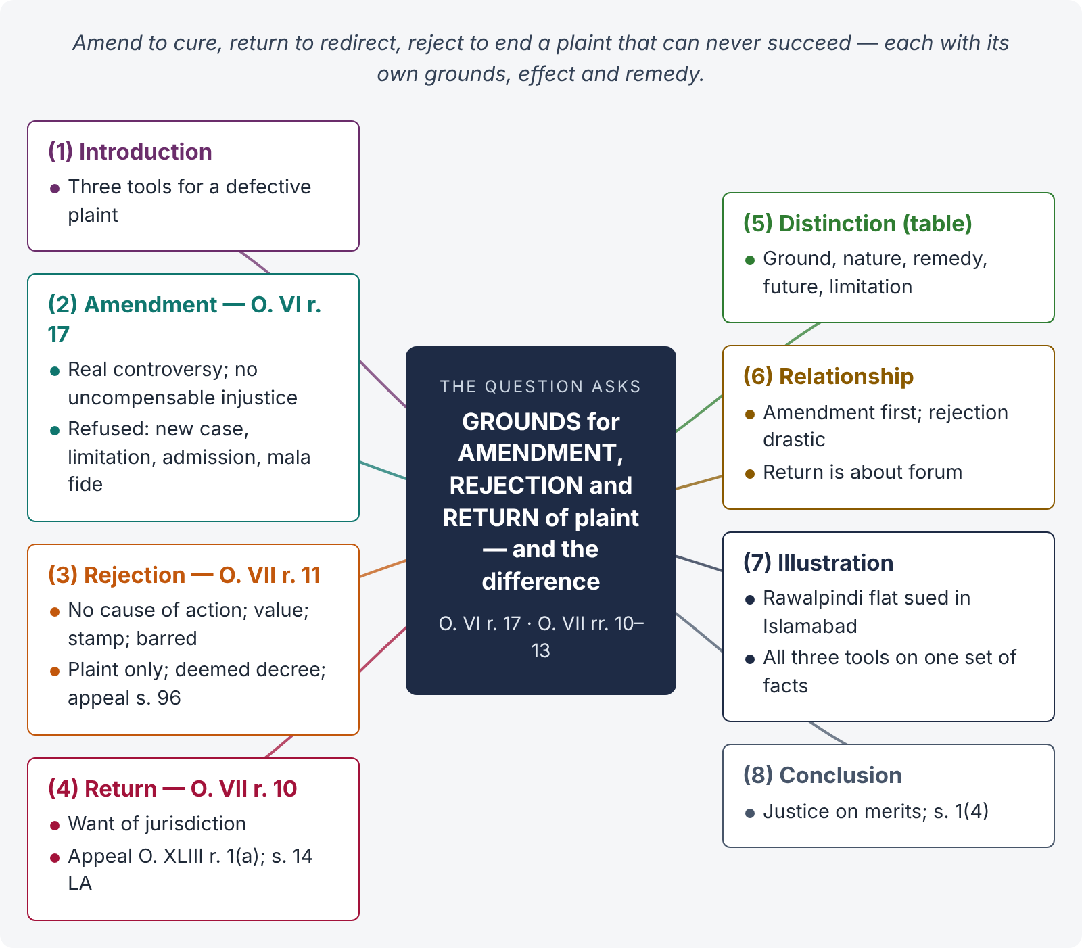
Figure 7 · The answer map: every branch is one numbered heading of the model answer below

Decoding the question
Three tools to deal with a defective plaint: amend it (O. VI r. 17), reject it (O. VII r. 11) or return it (O. VII r. 10). For each: the provision, the grounds, the principles the courts apply, the effect and the remedy. The KP version adds "difference" — a comparison table answers it.

The model answer

1. Introduction — three ways to deal with a defective plaint
A plaint (O. VII r. 1) begins the suit (s. 26). If it has a defect, the court may allow the plaintiff to cure it (amendment), end the suit at the threshold (rejection), or send the plaint to the right court (return). The choice depends on the nature of the defect.

2. Amendment of plaint — O. VI r. 17

i) The provision
"The Court may at any stage of the proceedings allow either party to alter or amend his pleadings in such manner and on such terms as may be just, and all such amendments shall be made as may be necessary for the purpose of determining the real questions in controversy between the parties."

ii) Grounds on which amendment is allowed
(1) It is necessary to decide the real controversy; (2) it causes no injustice to the other side that cannot be compensated by costs; (3) it is bona fide; (4) it avoids multiplicity of suits (e.g., adding a relief for possession after dispossession during the suit); (5) it corrects errors of description, dates or valuation.

iii) Grounds on which amendment is refused
(1) It changes the nature of the suit or sets up an entirely new and inconsistent case; (2) it would defeat a right accrued by limitation; (3) it withdraws an admission that benefits the other side; (4) it is mala fide or sought at a late stage merely to delay.

iv) Authority
Pirgonda Hongonda Patil v. Kalgonda (AIR 1957 SC 363): amendments should be allowed which are necessary to determine the real question and do not work injustice to the other side. L.J. Leach & Co. v. Jardine Skinner (AIR 1957 SC 357): even a time-barred amendment may be allowed in the interests of justice if the facts are already pleaded. The guiding maxim is that procedure is the handmaid of justice (Imtiaz Ahmad v. Ghulam Ali, PLD 1963 SC 382).

v) Time to amend — r. 18
If the party does not amend within the time fixed (or fourteen days), he cannot amend afterwards unless time is extended.

3. Rejection of plaint — O. VII r. 11

i) The four grounds
"The plaint shall be rejected in the following cases:— (a) where it does not disclose a cause of action; (b) where the relief claimed is under valued, and the plaintiff, on being required by the Court to correct the valuation within a time to be fixed by the Court, fails to do so; (c) where the relief claimed is properly valued, but the plaint is written upon paper insufficiently stamped, and the plaintiff, on being required … to supply the requisite stamp-paper …, fails to do so; (d) where the suit appears from the statement in the plaint to be barred by any law."

ii) Principles
(1) Only the plaint and documents annexed to it are considered; averments are assumed true; the written statement is irrelevant (Saleem Bhai v. State of Maharashtra, (2003) 1 SCC 557). (2) The plaint is read as a whole and meaningfully; clever drafting creating an illusion of a cause of action is to be "nipped in the bud" (T. Arivandandam v. T.V. Satyapal, (1977) 4 SCC 467). (3) The power may be exercised at any stage, even suo motu. (4) Under (b) and (c), the court must first give time to correct. (5) "Barred by any law" includes limitation, res judicata, s. 12(2) and statutory bars — if apparent from the plaint.

iii) Effect and remedy
The judge records an order with reasons (r. 12). Rejection is a deemed decree (s. 2(2)) — appealable under s. 96. Rejection does not of its own force bar a fresh plaint (r. 13).

4. Return of plaint — O. VII r. 10

i) The provision
"The plaint shall at any stage of the suit be returned to be presented to the Court in which the suit should have been instituted" (r. 10(1)). The judge endorses the dates of presentation and return, the name of the presenter and brief reasons (r. 10(2)).

ii) Grounds
The court lacks territorial or pecuniary jurisdiction (ss. 15–20 CPC; ss. 7, 9 Ordinance) — or, in some cases, subject-matter jurisdiction where another court can try the suit.

iii) Effect and remedy
The plaint is presented afresh in the proper court; time spent in the wrong court in good faith is excluded under s. 14 of the Limitation Act. An order returning a plaint is appealable under O. XLIII r. 1(a).

5. Distinction — return and rejection
Basis | Return (O. VII r. 10) | Rejection (O. VII r. 11)
Ground | Want of jurisdiction | No cause of action; undervaluation / stamp not cured; barred by law
Nature | Order | Deemed decree
Remedy | Appeal — O. XLIII r. 1(a) | Appeal — s. 96
Future | Same plaint in the proper court | Fresh plaint allowed (r. 13)
Limitation | s. 14 Limitation Act exclusion | No exclusion; must be within time
Merits | Not touched | Legal defect on the face of the plaint

6. Relationship between the three
Amendment is the first resort: where a defect can be cured (e.g., undervaluation, a missing averment of cause of action, a misdescribed property), the court should allow amendment rather than reject. Rejection is a drastic remedy for incurable defects. Return is a forum remedy: the plaint is fine but in the wrong court.

7. Illustration
Nadia sues in the Civil Court, Islamabad (East), for possession of a flat in Rawalpindi, valuing the suit at Rs. 10,000 though the flat is worth Rs. 18 million. (1) The court first orders her to correct the valuation (r. 11(b)); (2) after correction, the court has no territorial jurisdiction because the property is in Rawalpindi (s. 16), so it returns the plaint (r. 10); (3) if her plaint had disclosed no right at all (for example, admitting that she had sold the flat), it would be rejected (r. 11(a)); (4) a wrong khasra number could be cured by amendment (O. VI r. 17).

8. Conclusion
The CPC gives the court graduated tools: amend to cure, return to redirect, reject to end a plaint that can never succeed. The overriding principle — reinforced in Islamabad by the primary objective in s. 1(4) — is to decide cases justly and on merits while preventing abuse of the court's process.

Why this answer scores
- All three devices are covered with the exact grounds quoted from the bare Act.
- Principles from case law are given for amendment and rejection, not just the text.
- The comparison table answers the KP version of the question in seconds.
- The single illustration shows all three tools working on one set of facts.

Answer 7 · Misjoinder, non-joinder; necessary and proper parties (KPHC 2026)
AT A GLANCE · KP HIGH COURT 2026 · CIVIL LAW-I · Q. 3 · 20 MARKS
"No suit shall be defeated by reason of the misjoinder or non-joinder of parties, and the court may in every suit deal with the matter in controversy so far as regards the rights and interests of the parties actually before it." Explain how CPC, 1908, deals with different situations as to misjoinder, non-joinder, striking out, and proper and necessary parties to a suit.

The answer map
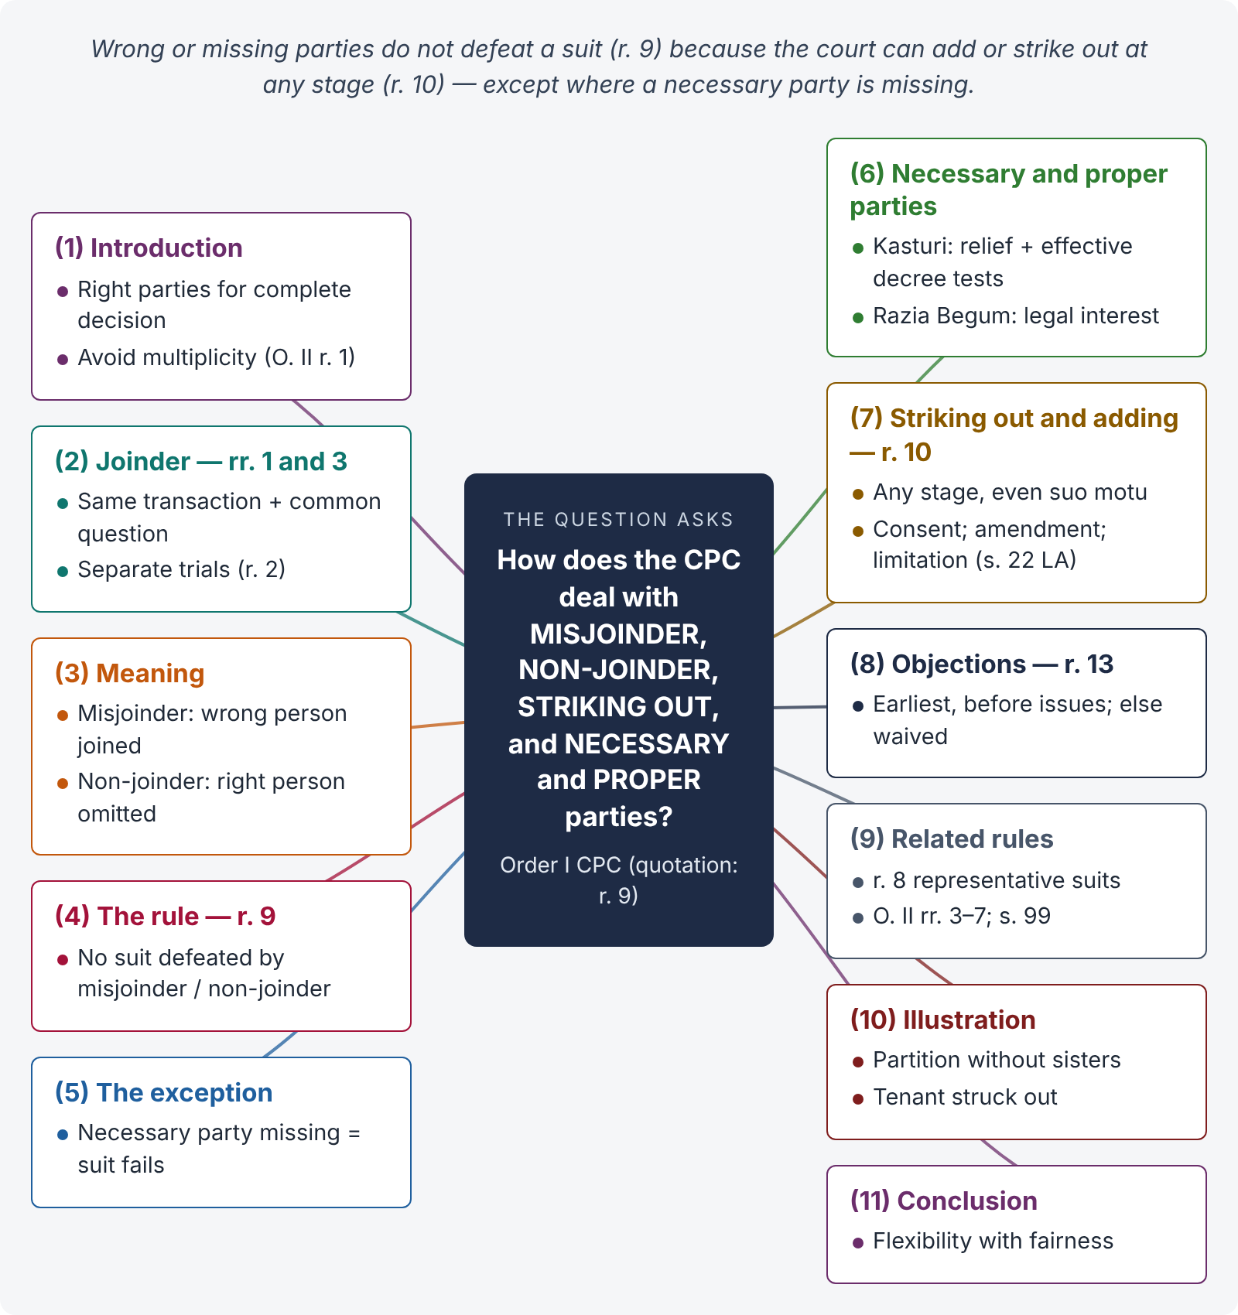
Figure 8 · The answer map: every branch is one numbered heading of the model answer below

Decoding the question
The quotation is O. I r. 9. The examiner wants the scheme of Order I: who may be joined (rr. 1, 3), what misjoinder and non-joinder mean, the rule that they do not defeat a suit, the exception for necessary parties, the power to add or strike out (r. 10), the time for objections (r. 13), and the necessary vs proper distinction with cases.

The model answer

1. Introduction — the right parties for a complete decision
A suit must be framed "so as to afford ground for final decision upon the subjects in dispute and to prevent further litigation concerning them" (O. II r. 1). Order I tells us who must or may be before the court. The policy is to avoid multiplicity of suits while ensuring that no person is bound by a decree without being heard.

2. Joinder of plaintiffs and defendants — rr. 1 and 3
All persons may be joined as plaintiffs (r. 1) or defendants (r. 3) where (i) the right to relief arises from the same act or transaction or series of transactions, and (ii) a common question of law or fact would arise in separate suits. The court may order separate trials if joinder may embarrass or delay (r. 2); a defendant need not be interested in all reliefs (r. 5); a plaintiff in doubt may join defendants in the alternative (r. 7).

3. Misjoinder and non-joinder — meaning

i) Misjoinder
Joining a person who ought not to be a party — against whom no relief is claimed, or whose claim has no common transaction or question with the others.

ii) Non-joinder
Omitting a person who ought to have been joined.

4. The rule — O. I r. 9
"No suit shall be defeated by reason of the misjoinder or non-joinder of parties, and the Court may in every suit deal with the matter in controversy so far as regards the rights and interests of the parties actually before it." Defects of parties are procedural; the court corrects them (r. 10) and decides between those present.

5. The exception — non-joinder of a necessary party
The protection of r. 9 does not extend to a necessary party. If a person without whom no effective decree can be passed is not joined, and the plaintiff does not add him despite objection or opportunity, the suit fails. The court cannot pass a decree that binds or affects an absent person who is indispensable.

6. Necessary and proper parties

i) Necessary party
A person (a) against whom some relief is claimed in respect of the controversy, and (b) in whose absence no effective decree can be passed (Kasturi v. Iyyamperumal, (2005) 6 SCC 733). Examples: all co-sharers in a partition suit; the vendee in a suit to cancel a sale deed; the principal in a suit on a contract made by a disclosed agent.

ii) Proper party
A person whose presence is not indispensable, but who helps the court to effectually and completely adjudicate (O. I r. 10(2)) — e.g., a tenant in a suit for possession against the landlord-owner, or a subsequent purchaser with notice in a specific performance suit.

iii) The limit
A stranger claiming an independent, adverse title is neither necessary nor proper in a suit for specific performance, because the court will not convert a contract suit into a title suit (Kasturi). A person with only an indirect or commercial interest is not added (Razia Begum v. Sahebzadi Anwar Begum, AIR 1958 SC 886).

7. Striking out and adding parties — O. I r. 10

i) Wrong plaintiff — r. 10(1)
Where a suit is filed in the name of the wrong plaintiff through a bona fide mistake, the court may substitute or add the right plaintiff at any stage.

ii) The general power — r. 10(2)
"The Court may at any stage of the proceedings, either upon or without the application of either party, … order that the name of any party improperly joined … be struck out, and that the name of any person who ought to have been joined … or whose presence before the Court may be necessary in order to enable the Court effectually and completely to adjudicate upon and settle all the questions involved in the suit, be added."

iii) Safeguards
No one is added as a plaintiff without his consent (r. 10(3)); the plaint is amended and served on the added defendant (r. 10(4)); for limitation, the suit against an added defendant begins when he is made a party (r. 10(5) with s. 22 Limitation Act) — so a time-barred claim is not revived by adding him.

8. Objections — O. I r. 13
"All objections on the ground of non-joinder or misjoinder of parties shall be taken at the earliest possible opportunity and, in all cases where issues are settled, at or before such settlement, … and any such objection not so taken shall be deemed to have been waived." (Non-joinder of a necessary party, however, goes to the root and can be noticed later, because no effective decree is possible.)

9. Related rules
- Representative suits — O. I r. 8: numerous persons with the same interest; permission and notice; decree binds all (s. 11 Expl. VI).
- Misjoinder of causes of action — O. II rr. 3, 6, 7: separate trials; objection before issues.
- Appeal — no decree is reversed for misjoinder not affecting the merits or jurisdiction (s. 99).

10. Illustration
Shazia sues her brother Kamran alone for partition of their late father's house in G-6, omitting their two sisters. Kamran objects in his written statement. Non-joinder of necessary parties: no effective partition can be made without all co-sharers. The court should add the sisters under r. 10(2), even suo motu; if Shazia refuses to implead them, the suit must fail. If she had also joined her father's former tenant (no claim against him), that is misjoinder; his name will be struck out — the suit is not defeated (r. 9).

11. Conclusion
Order I combines flexibility with fairness: wrong or missing parties do not defeat a suit (r. 9), because the court can add or strike out parties at any stage (r. 10); objections must be taken early (r. 13). But the flexibility stops where justice requires a person's presence: without a necessary party no effective decree can be passed. The distinction between necessary and proper parties, settled in Kasturi and Razia Begum, is the key to applying r. 9 correctly.

Why this answer scores
- It identifies the quotation as O. I r. 9 and immediately states the exception — the heart of the question.
- Every situation in the question is covered: misjoinder, non-joinder, striking out, necessary and proper parties.
- Two leading cases give the tests for necessary parties and the limits of joinder.
- The limitation point (r. 10(5) and s. 22 Limitation Act) shows depth.

Answer 8 · Setting aside ex parte orders and decrees; dismissal for default (LHC 2020)
AT A GLANCE · LHC CIVIL JUDGE EXAM 2020 · CIVIL LAW-II · Q. 3 · 20 MARKS
Discuss all specific provisions of C.P.C. for setting aside ex parte orders, judgments and decrees. Dismissal of the suit in presence or absence of defendants. (Related: PU LLB 2007 — "Enumerate the difference between order for ex parte proceedings and an ex parte decree. Also suggest the remedies.")

The answer map
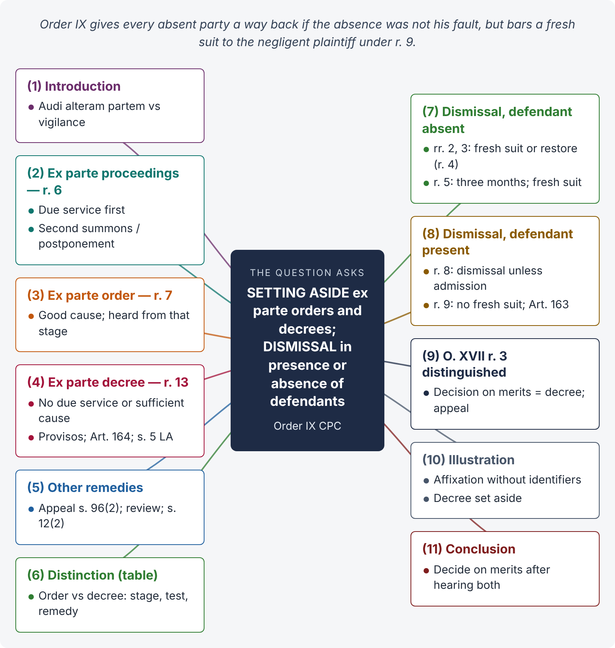
Figure 9 · The answer map: every branch is one numbered heading of the model answer below

Decoding the question
Two halves. (1) Ex parte: when the court proceeds ex parte (O. IX r. 6), the remedy before the decree (r. 7, "good cause") and after the decree (r. 13, "sufficient cause" / no due service), plus appeal, review and s. 12(2). (2) Dismissal: when the suit is dismissed with the defendant present (r. 8) or absent (rr. 2, 3, 5), and the remedies (restoration, fresh suit, bar of r. 9). Limitation (Arts. 163, 164) and appeals (O. XLIII) complete the answer.

The model answer

1. Introduction — balancing hearing and diligence
Order IX regulates the consequences of non-appearance. It protects the right to be heard (audi alteram partem) while refusing help to the negligent (vigilantibus non dormientibus jura subveniunt). It provides for ex parte proceedings and decrees against an absent defendant, dismissal against an absent plaintiff, and remedies to undo both where there was good reason.

2. When the court proceeds ex parte — r. 6
Where the plaintiff appears and the defendant does not: "(a) if it is proved that the summons was duly served, the Court may proceed ex parte and pass decree without recording evidence; (b) if it is not proved that the summons was duly served, the Court shall direct a second summons…; (c) if … served … but not in sufficient time…, the Court shall postpone the hearing." The court must therefore first be satisfied about due service (O. V rr. 10-A, 17, 19, 20).

3. Remedy against an ex parte order — r. 7
"Where the Court has adjourned the hearing of the suit ex parte, and the defendant, at or before such hearing, appears and assigns good cause for his previous non-appearance, he may, upon such terms as the Court directs as to costs or otherwise, be heard in answer to the suit as if he had appeared on the day fixed for his appearance." The defendant joins the proceedings from that stage; he cannot always reopen what was done in his absence.

4. Remedy against an ex parte decree — r. 13

i) The provision
"In any case in which a decree is passed ex parte against a defendant, he may apply to the Court by which the decree was passed for an order to set it aside; and if he satisfies the Court that the summons was not duly served, or that he was prevented by any sufficient cause from appearing when the suit was called on for hearing, the Court shall make an order setting aside the decree … upon such terms as to costs, payment into Court or otherwise as it thinks fit."

ii) The two provisos
(a) If the decree cannot be set aside against one defendant only, it may be set aside against all. (b) "No decree passed ex parte shall be set aside merely on the ground of any irregularity in the service of summons, if the Court is satisfied, for reason to be recorded, that the defendant had knowledge of the date of hearing in sufficient time to appear."

iii) Sufficient cause
A cause beyond the party's control, without negligence and with bona fides — illness, accident, mistake of counsel. It is construed liberally to advance substantial justice (G.P. Srivastava v. R.K. Raizada, (2000) 3 SCC 54), but not to reward carelessness (Parimal v. Veena, (2011) 3 SCC 545).

iv) Procedure and limitation
Notice to the opposite party is compulsory (r. 14). Limitation: Article 164 of the Limitation Act — 30 days from the date of the decree, or, where the summons was not duly served, from the date of knowledge of the decree; s. 5 of the Limitation Act applies (r. 13(2)). An order rejecting the application is appealable (O. XLIII r. 1(d)).

5. Other remedies against an ex parte decree
- Appeal under s. 96 — the Islamabad text expressly says "An appeal may lie from an original decree passed ex-parte" (s. 96(2), Act XIX of 2023).
- Review under s. 114 / O. XLVII — error apparent on the record or new evidence.
- Section 12(2) — where the decree was obtained by fraud or misrepresentation (e.g., a false address to avoid service) or without jurisdiction.
Both r. 13 and appeal may be pursued, but once the appeal is decided on merits, the trial decree merges into the appellate decree (Bhanu Kumar Jain v. Archana Kumar, (2005) 1 SCC 787).

6. Ex parte order and ex parte decree distinguished
Basis | Ex parte order | Ex parte decree
Stage | During the suit | At its end
Remedy | r. 7 — appear and show good cause | r. 13 — sufficient cause or no due service; appeal; review; s. 12(2)
Effect of success | Defendant heard from that stage | Decree set aside; suit restored
Appeal | None | Rejection appealable — O. XLIII r. 1(d)

7. Dismissal in the absence of the defendant — rr. 2, 3 and 5
- r. 2: summons not served because the plaintiff did not pay process fee — suit may be dismissed (not if the defendant appears anyway).
- r. 3: neither party appears — suit may be dismissed.
- Remedy (r. 4): the plaintiff may bring a fresh suit (subject to limitation) or apply for restoration on sufficient cause.
- r. 5: summons returned unserved and the plaintiff fails for three months to apply for fresh summons — the court shall dismiss the suit against that defendant (unless diligence, evasion or other sufficient cause is shown); fresh suit allowed (r. 5(2)).

8. Dismissal in the presence of the defendant — rr. 8 and 9

i) r. 8
"Where the defendant appears and the plaintiff does not appear when the suit is called on for hearing, the Court shall make an order that the suit be dismissed, unless the defendant admits the claim, or part thereof, in which case the Court shall pass a decree against the defendant upon such admission."

ii) r. 9
The plaintiff is precluded from bringing a fresh suit on the same cause of action (see also s. 12(1)); but he may apply to set aside the dismissal on sufficient cause, with notice to the other side; s. 5 Limitation Act applies. Limitation: Article 163 — 30 days from dismissal. Rejection of the application is appealable (O. XLIII r. 1(c)).

9. Distinguish O. XVII r. 3
Where the plaintiff was given time to produce evidence and defaulted, the court may "proceed to decide the suit forthwith" (O. XVII r. 3). That is a decision on merits — a decree appealable under s. 96 — not a dismissal for default under O. IX. The remedy is appeal, not restoration.

10. Illustration
Bashir is sued for Rs. 3 million. The process server affixes the summons without naming identifiers; the court does not examine him (O. V r. 19); the registered summons returns "addressee left". An ex parte decree follows. Bashir learns of it four months later when his account is attached. Service was not due; limitation under Art. 164 runs from knowledge; the second proviso does not apply (no proof he knew the date). The decree should be set aside under r. 13 on such terms as to costs as the court thinks fit, and the suit restored for trial.

11. Conclusion
Order IX gives every absent party a way back if his absence was not his fault — r. 7 (good cause) during the suit, r. 13 (sufficient cause or no due service) after an ex parte decree, r. 4 and r. 9 after dismissal — while making the negligent plaintiff pay the price of r. 9's bar on a fresh suit. Appeal (s. 96(2)), review and s. 12(2) supplement these remedies. The guiding principle remains that cases should, as far as possible, be decided on merits after hearing both sides.

Why this answer scores
- Both halves of the question are answered — ex parte remedies and dismissals (with and without the defendant).
- The exact grounds of r. 13, both provisos, the limitation articles (163, 164) and appeals (O. XLIII) are given.
- The comparison table answers the related LLB question directly.
- Islamabad's s. 96(2) and the O. XVII r. 3 distinction show depth beyond the textbook.

Answer 9 · Frame the appropriate issues — recovery suit (LHC 2017)
AT A GLANCE · LHC CIVIL JUDGE EXAM 2017 · CIVIL LAW-II · Q. 3 · 20 MARKS
Ahmed supplied certain goods worth Rs. 2.00 million received by Zahid on behalf of his employer, namely, Babar. However, on account of the non-payment of the outstanding amount (Rs. 2.00 million) within the stipulated period, Ahmed filed a recovery suit against Zahid. In a written statement, Zahid controverted the contents of the plaint and asserted that said amount was outstanding against Babar. He also raised preliminary objections regarding maintainability of suit, limitation, deficient court fee, non-joinder of parties, false and vexatious claim, and exemplary costs. Dismissal of the suit was also prayed for. In light of the above facts, frame the appropriate issues.

The answer map
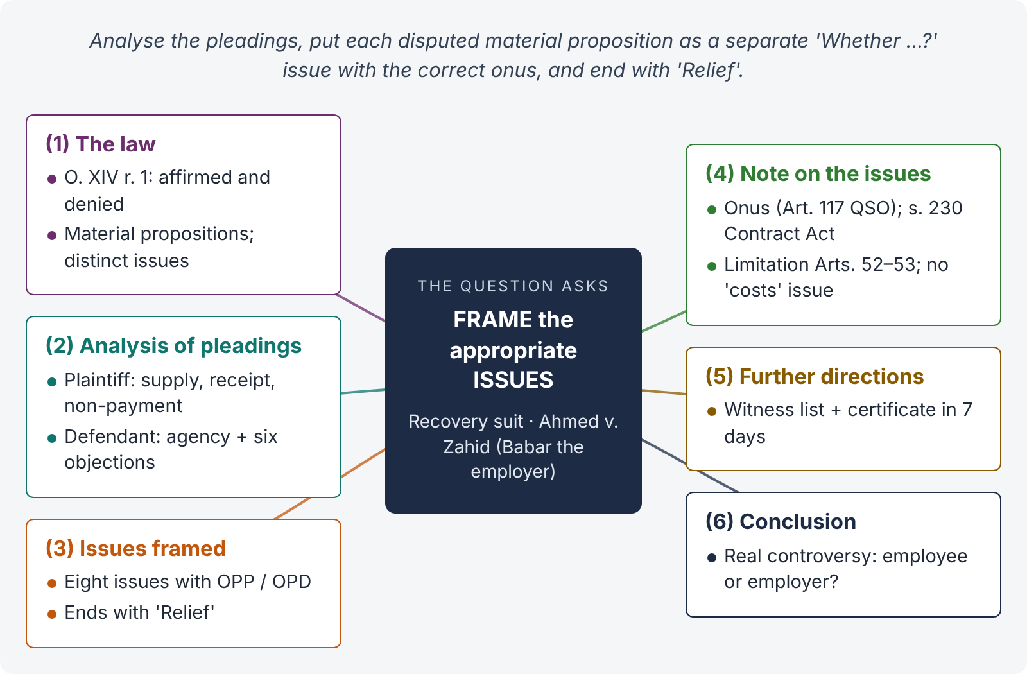
Figure 10 · The answer map: every branch is one numbered heading of the model answer below

Decoding the question
This is the practical skill the IHC syllabus promises to test. The examiner wants (1) a brief statement of the law of issues (O. XIV r. 1), (2) an analysis of the pleadings — what is affirmed, denied and newly pleaded, (3) correctly worded issues with the onus (OPP / OPD), and (4) a short note explaining choices (e.g., why "exemplary costs" is not a separate issue; which issues can be tried first). Write it as a judge would record it.

The model answer

1. The law — what an issue is
"Issues arise when a material proposition of fact or law is affirmed by the one party and denied by the other" (O. XIV r. 1(1)). "Material propositions are those propositions of law or fact which a plaintiff must allege in order to show a right to sue or a defendant must allege in order to constitute his defence" (r. 1(2)). "Each material proposition affirmed by one party and denied by the other shall form the subject of a distinct issue" (r. 1(3)). The court frames issues from the pleadings, statements of the parties and documents (r. 3).

2. Analysis of the pleadings

i) Plaintiff's material propositions
(a) Ahmed supplied goods worth Rs. 2,000,000; (b) the goods were received by Zahid; (c) payment was due within a stipulated period and was not made; (d) Zahid is liable to pay.

ii) Defendant's denials and new pleas
(a) Denies liability: the goods were received on behalf of his employer Babar, against whom the amount is outstanding — a plea of agency; (b) preliminary objections: maintainability, limitation, deficient court fee, non-joinder (of Babar), suit false and vexatious, and exemplary costs.

iii) Admitted facts
Zahid does not deny that the goods were supplied or received by him; his case is that he received them for Babar. (Even so, the supply and outstanding amount should be put in issue because he "controverted the contents of the plaint" generally.)

3. Issues framed
ISSUES · In the Court of Civil Judge 1st Class, Islamabad · Civil Suit No. ___ · Ahmed v. Zahid (Recovery of Rs. 2,000,000)
- Whether the suit is not maintainable in its present form? OPD
- Whether the suit is barred by limitation? OPD
- Whether the suit has not been properly valued for the purposes of court fee and jurisdiction, and the court fee affixed is deficient? OPD
- Whether the suit is bad for non-joinder of Babar, a necessary party? OPD
- Whether the plaintiff supplied goods worth Rs. 2,000,000 which were received by the defendant, and the said amount is outstanding and recoverable from the defendant? OPP
- Whether the defendant received the goods only as an employee / agent for and on behalf of his disclosed principal (employer) Babar and is, therefore, not personally liable to pay the price? OPD
- Whether the suit is false and vexatious to the knowledge of the plaintiff and the defendant is entitled to special costs under section 35B CPC? OPD
- Relief.

4. Note on the issues — why framed this way

i) Onus
The plaintiff must prove his own case (supply, receipt, non-payment) — Issue 5, OPP. The defendant must prove every special plea he raised — agency, limitation, valuation, non-joinder, falsity — OPD. "Whoever desires any Court to give judgment as to any legal right or liability dependent on the existence of facts which he asserts, must prove that those facts exist" (Art. 117, Qanun-e-Shahadat 1984).

ii) Issue 6 — the real controversy
Under s. 230 of the Contract Act 1872, an agent cannot, in the absence of a contract to that effect, personally enforce contracts entered into on behalf of his principal, nor is he personally bound by them — subject to exceptions (e.g., where the principal is undisclosed or the agent agreed to be personally liable). Whether Zahid acted for a disclosed principal is therefore decisive.

iii) Issue 4 — non-joinder
If Babar is the real buyer, he is a necessary party (no effective decree for the price can be passed against him in his absence). Under O. I r. 9 the suit is not defeated by non-joinder of a proper party, but non-joinder of a necessary party not cured is fatal; the plaintiff may apply under O. I r. 10(2) to implead Babar.

iv) Issue 2 — limitation
The suit is for the price of goods sold and delivered. Limitation is three years (Limitation Act, First Schedule, Art. 52 — from delivery where no credit period is fixed; Art. 53 where a fixed period of credit is agreed — from expiry of that period). If the dates are admitted, the issue can be decided first as an issue of law under O. XIV r. 2.

v) Why no separate issue on "exemplary costs"
Costs are not a cause of action and need no issue. The plea is covered by Issue 7 (special costs under s. 35B) and by the court's power to award actual costs under s. 35 (Islamabad text) at the end of the case.

vi) Issue 1 — maintainability
The defendant pleaded it generally. In the judgment, the court will decide it together with Issues 4 and 6 (a suit against an agent of a disclosed principal may be held not maintainable against him).

5. Further directions after framing issues
"Parties to file list of witnesses and certificate of readiness within seven days (O. XVI r. 1). Plaintiff's evidence on the next date. The suit will be fixed for evidence of the plaintiff first, as the onus of the main issue (Issue 5) is on him; defendant's evidence thereafter."

6. Conclusion
The issues capture every material proposition in dispute: the plaintiff's claim (Issue 5), the defendant's agency defence (Issue 6), the legal objections (Issues 1–4), and the plea of false claim (Issue 7), with the onus placed on the party who asserts. Framed this way, the trial will focus on the true controversy — who is liable for the price: the employee who received the goods, or his employer?

Why this answer scores
- It starts with the law (O. XIV r. 1) in two lines and then does what a judge does: analyses the pleadings.
- The issues are precise, separate and correctly onused (OPP / OPD), ending with "Relief".
- The note explains each choice and links the procedure to substantive law — s. 230 Contract Act and the Limitation Act — which impresses examiners.
- It knows what not to frame (no issue on "exemplary costs"; costs under ss. 35, 35B).

Answer 10 · Write an order on an application under Order VII rule 11 (model question, IHC pattern)
AT A GLANCE · MODEL QUESTION · IHC SYLLABUS PATTERN ("give the facts of a typical case … write a judgment") · 20 MARKS
Ali Raza filed a suit for declaration and permanent injunction in the court of a Civil Judge at Islamabad against the Capital Housing Authority (CHA), a statutory body under the (hypothetical) Capital Housing Authority Act. He pleaded that Plot No. 22, Street 9, Sector I-14/2, was allotted to him in 2019; he paid all instalments; on 03.02.2026 the CHA cancelled the allotment without any show-cause notice or hearing, alleging non-payment, and re-allotted the plot to another person. He prayed for a declaration that the cancellation is illegal and void, and an injunction restraining the CHA from creating third-party rights. The CHA filed an application under Order VII rule 11 CPC for rejection of the plaint on the grounds that (i) section 40 of the CHA Act provides that "no order passed by the Authority under this Act shall be called in question in any court", and the Act provides an appeal to the Chairman CHA within 30 days; and (ii) the plaint does not disclose a cause of action. The plaintiff resisted the application. Write a reasoned order on the application.

The answer map
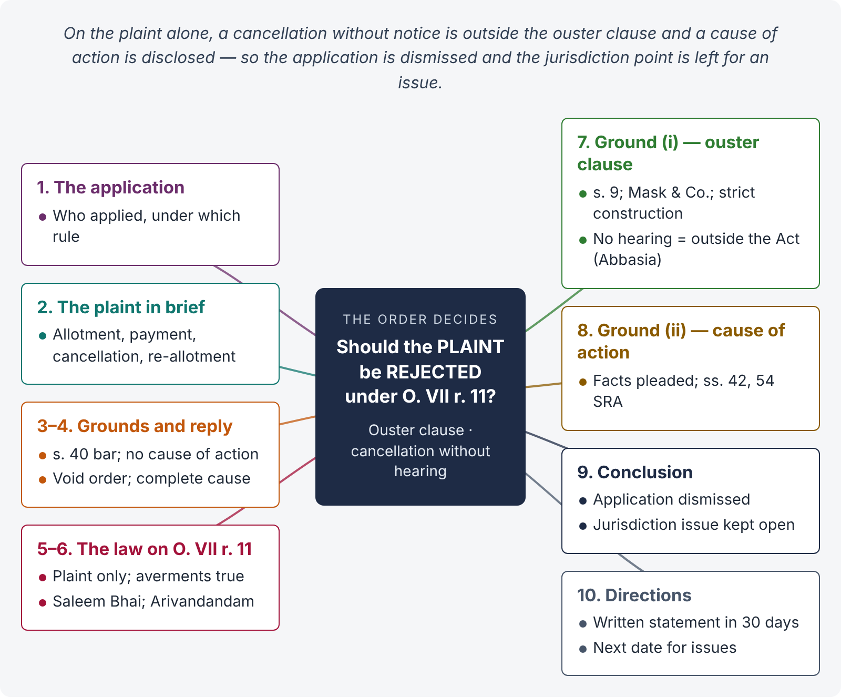
Figure 11 · The answer map: every branch is one numbered heading of the model answer below

Decoding the question
The examiner wants a court order — in the right format — that applies the law of O. VII r. 11 (only the plaint is seen) and s. 9 (ouster clauses do not protect orders without jurisdiction, mala fide or against natural justice) to the facts. The order must decide each ground, give reasons, and end with a clear operative part. Remember: in Islamabad, s. 151 powers must be exercised "after recording reasons"; s. 1(4) asks the court to deal with cases "justly and fairly".

The model answer
ORDER · IN THE COURT OF CIVIL JUDGE 1st CLASS, ISLAMABAD (WEST)
Civil Suit No. ___ of 2026 · Ali Raza v. Capital Housing Authority and another · Suit for declaration and permanent injunction
ORDER (on the application of defendant No. 1 under Order VII rule 11 CPC)
- The application. Through this order I shall decide the application of defendant No. 1, the Capital Housing Authority (CHA), under Order VII rule 11 CPC for rejection of the plaint.
- The plaint in brief. The plaintiff asserts that Plot No. 22, Street 9, Sector I-14/2, was allotted to him in 2019; that he paid all instalments; and that on 03.02.2026 the CHA cancelled the allotment, alleging non-payment, without issuing any show-cause notice or affording a hearing, and re-allotted the plot. He seeks a declaration that the cancellation is illegal and void and an injunction against the creation of third-party rights.
- Grounds of the application. The CHA contends that (i) the suit is barred by section 40 of the CHA Act, which provides that no order of the Authority "shall be called in question in any court", and that the plaintiff should have availed the departmental appeal; and (ii) the plaint discloses no cause of action.
- Reply. The plaintiff contends that the cancellation was made without notice and hearing, is void, and is not protected by the ouster clause; and that the plaint discloses a complete cause of action.
- Arguments heard; record perused.
- The law on Order VII rule 11. The rule requires rejection where the plaint "does not disclose a cause of action" (clause (a)) or "where the suit appears from the statement in the plaint to be barred by any law" (clause (d)). At this stage the court looks only at the averments in the plaint and the documents annexed to it, assuming them to be correct; the defence is irrelevant (Saleem Bhai v. State of Maharashtra, (2003) 1 SCC 557). The plaint is read as a whole and meaningfully (T. Arivandandam v. T.V. Satyapal, (1977) 4 SCC 467). Rejection is a drastic power, to be used only where the bar or the absence of a cause of action is clear on the face of the plaint.
- Ground (i) — bar of section 40 of the CHA Act. Under section 9 CPC, civil courts try all suits of a civil nature "excepting suits of which their cognizance is either expressly or impliedly barred". Exclusion of jurisdiction is not readily inferred and ouster clauses are strictly construed (Secretary of State v. Mask & Co., AIR 1940 PC 105). It is settled that even where a statute ousts the civil court, the court retains jurisdiction to examine an order which is without jurisdiction, mala fide, coram non judice or passed in violation of the principles of natural justice, because such an order is not an order "under the Act" (Abbasia Cooperative Bank v. Hakeem Hafiz Muhammad Ghaus, PLD 1997 SC 3). The plaint specifically avers that the cancellation was made without show-cause notice or hearing, despite payment of all instalments. Taking these averments as true, the impugned order, if proved, is one made in violation of audi alteram partem and would fall outside the protection of section 40. The availability of a departmental appeal does not bar a civil suit against a void order. Whether the averments are true is a matter for evidence. The bar is therefore not apparent from the plaint.
- Ground (ii) — cause of action. The plaint pleads the allotment, full payment, the cancellation without notice, and re-allotment to a third person, with dates. These facts, if proved, entitle the plaintiff to the declaration and injunction prayed for under sections 42 and 54 of the Specific Relief Act 1877. The plaint therefore discloses a cause of action.
- Conclusion. The plaint neither fails to disclose a cause of action nor appears from its own statements to be barred by any law. The objections raised by the CHA involve disputed questions of fact (whether instalments were paid; whether notice was issued) which can be decided only after evidence. The application under Order VII rule 11 CPC is dismissed. The objection of jurisdiction shall, however, remain open and an appropriate issue shall be framed on it, to be decided with the other issues after evidence. Costs of the application shall abide the event.
- Defendant No. 1 to file its written statement within thirty days (Order VIII rule 1 CPC). To come up on ___ for written statement and framing of issues.
Announced in open court · Dated ___ · Civil Judge 1st Class, Islamabad (West) (seal)

Points of law used in the order
- O. VII r. 11(a) and (d) — look only at the plaint (Saleem Bhai; Arivandandam).
- s. 9 CPC — presumption in favour of jurisdiction; strict construction of ouster clauses (Mask & Co.).
- Ouster clauses do not protect orders without jurisdiction, mala fide, coram non judice or against natural justice (Abbasia Cooperative Bank, PLD 1997 SC 3; Dhulabhai, AIR 1969 SC 78).
- Disputed facts mean the plaint cannot be rejected; frame an issue instead (O. XIV r. 1; r. 2 only if decidable without evidence).
- Specific Relief Act ss. 42 and 54 — declaration and perpetual injunction (Civil Law-II).

Alternative outcome — when the plaint would be rejected
If the plaint itself had admitted that the plaintiff was given notice and a hearing, and had only attacked the CHA's assessment of the facts (e.g., that the default was minor), the order would be within the statute; the civil court could not sit in appeal over it, and the bar of section 40 would be apparent from the plaint. The plaint would then be rejected under O. VII r. 11(d), leaving the plaintiff to his statutory appeal.

Why this answer scores
- It is written in the form of a real court order — heading, title, numbered paragraphs, operative part, date and signature — exactly what the IHC syllabus says will be tested.
- It applies the correct test for O. VII r. 11 (plaint only) and the correct law on ouster clauses, each with authority.
- It decides every ground separately and gives reasons.
- It shows judicial maturity: the jurisdiction question is kept open as an issue, and the alternative outcome shows the examiner the candidate understands where the line falls.

